**COMP3010 CW2**

Contents

Introduction: 2

SOC Roles and Incident Handling Reflection: 2

Installation and Data Preparation: 2

Splunk Installation: 2

BOTSv3 Dataset Preparation: 11

Guided Questions: 12

Question 1: 12

Question 2: 12

Question 3: 13

Question 4: 14

Question 5: 15

Question 6: 15

Question 7: 16

Question 8: 17

Conclusions: 18

References: 18

# Introduction:

# SOC Roles and Incident Handling Reflection:

# Installation and Data Preparation:

This section will explain how Splunk was installed within an Ubuntu Linux virtual machine, as well as how the BOTSv3 dataset was loaded. As I performed the installation before taking screenshots for this section, the screenshots display later timestamps compared to those for the guided questions. To effectively demonstrate the installation of Splunk, I reinstalled it on the same virtual machine which ensured the configuration of the machine remained the same throughout this report.

## Splunk Installation:

To begin, I opened Firefox inside an Ubuntu Linux virtual machine and searched for “splunk enterprise download”, clicking on the first link in the search results.

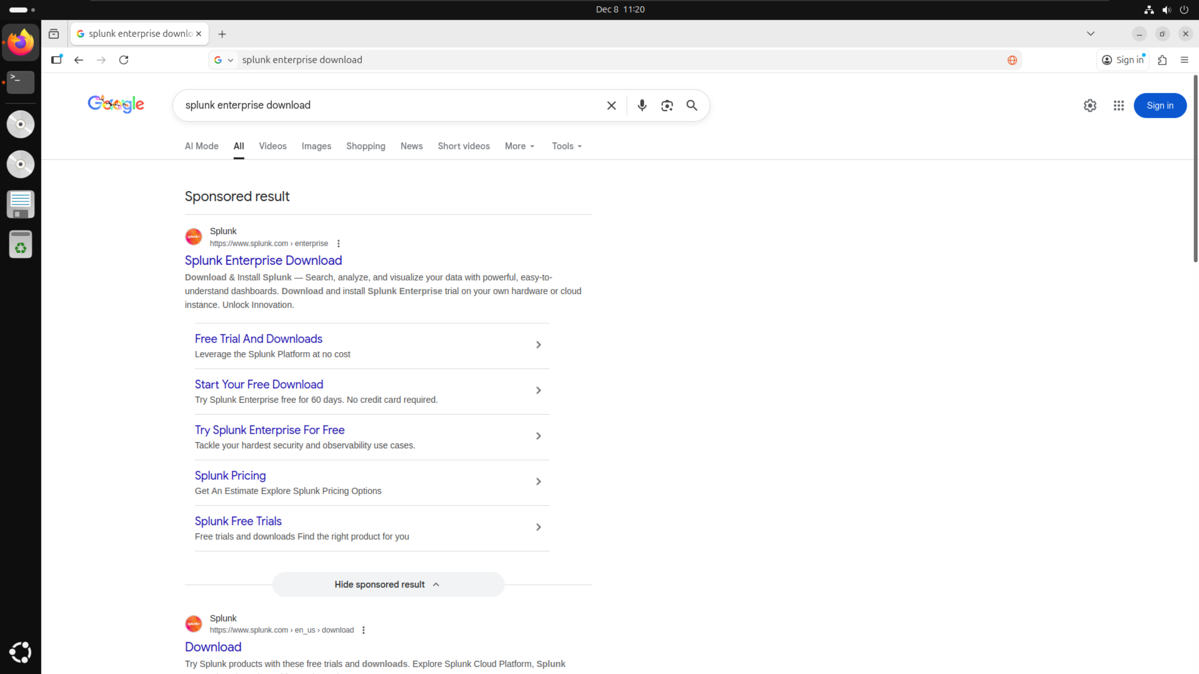

This link took me to the official Splunk website, where I then logged into my account using an account which I had already created.

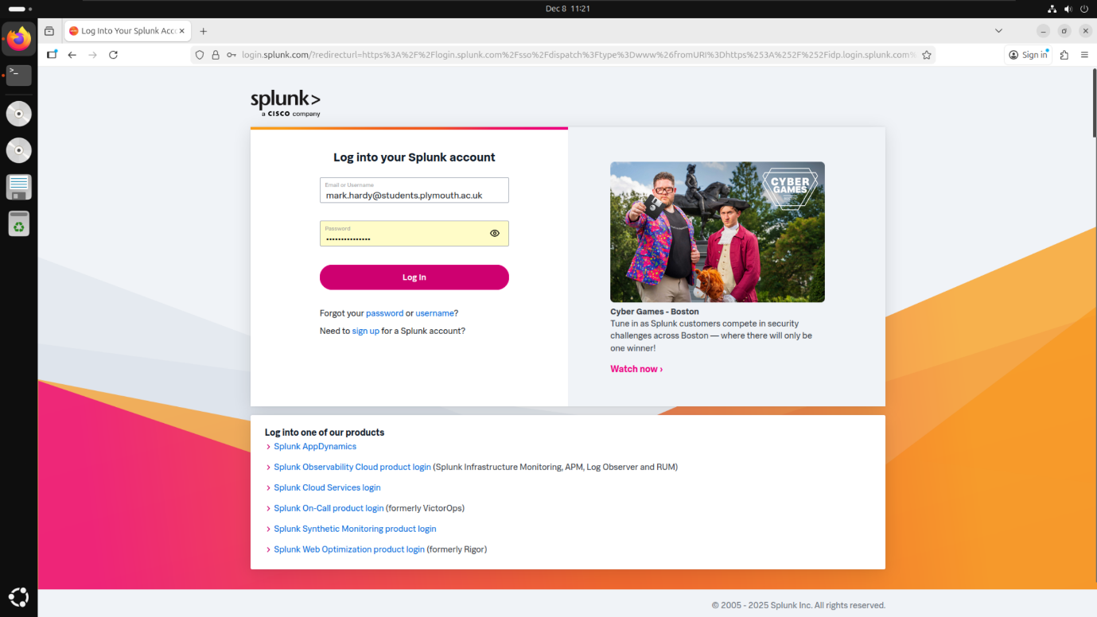

On the “Choose Your Download” page, I selected “Copy wget link” for the .tgz version of Splunk, to ensure that all packages were downloaded alongside the main Splunk software. This meant I did not have to individually download all relevant packages to complete this coursework.

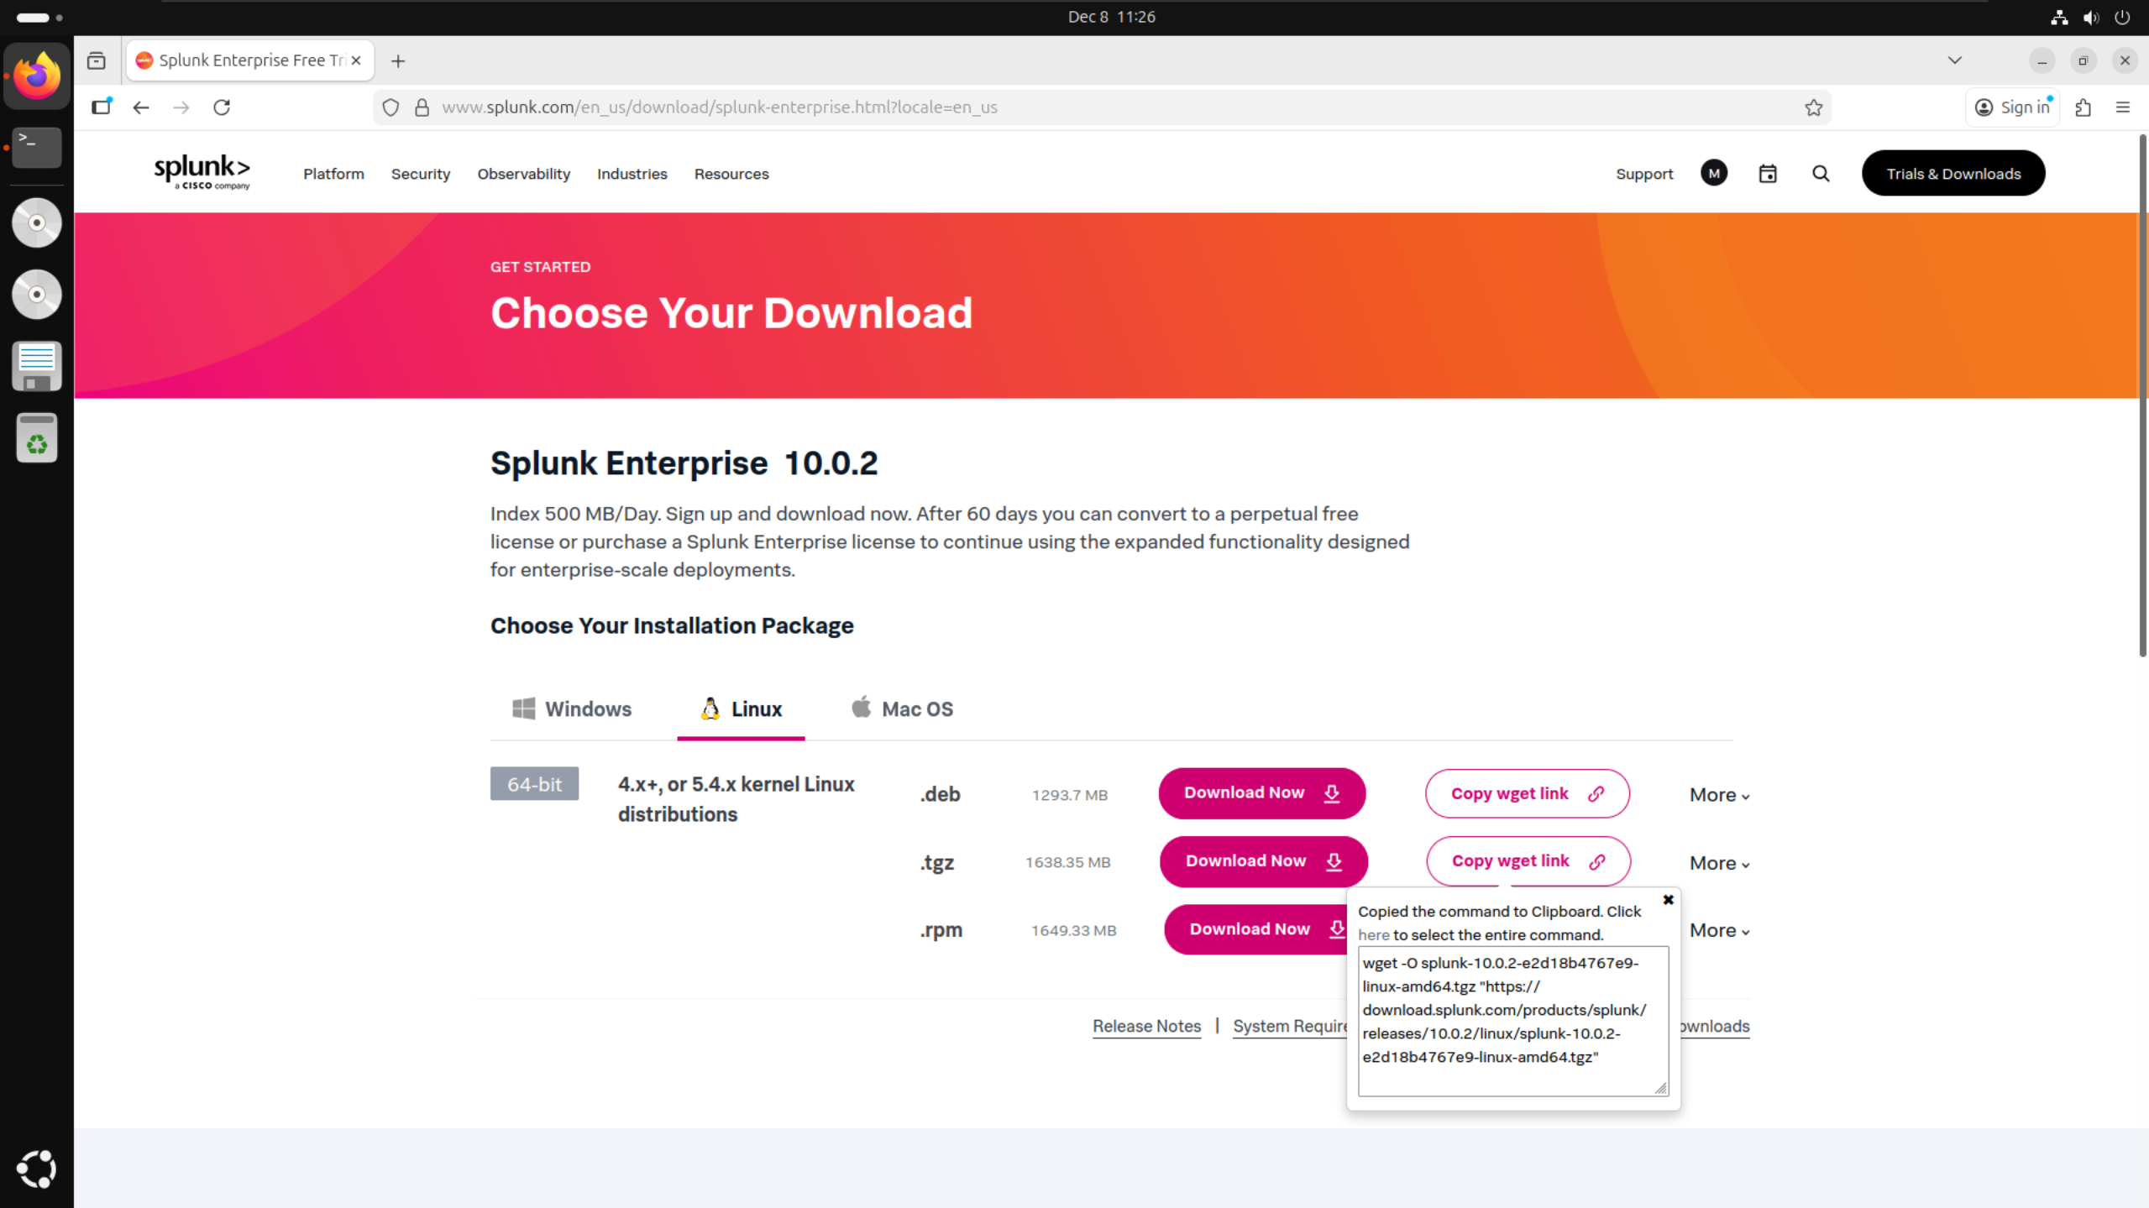

By using the wget link, I was then able to download Splunk directly from the Linux terminal by pasting the link directly into the terminal and running it. I then received a confirmation message in the terminal to state that Splunk had been successfully downloaded.

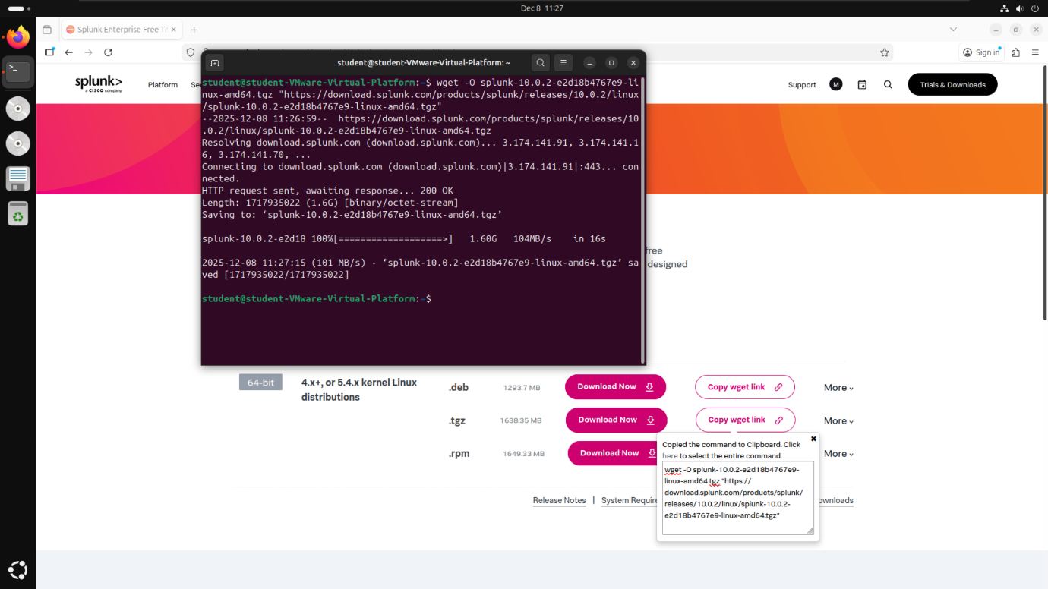

I then ran the command “sudo tar xvzf splunk-10.0.2-e2d18b4767e9-linux-amd64.tgz -C /opt” which installed Splunk and all it’s dependencies into the /opt folder. While performing the install, the terminal showed an updated list of every file being installed alongside the folders they were being installed into.

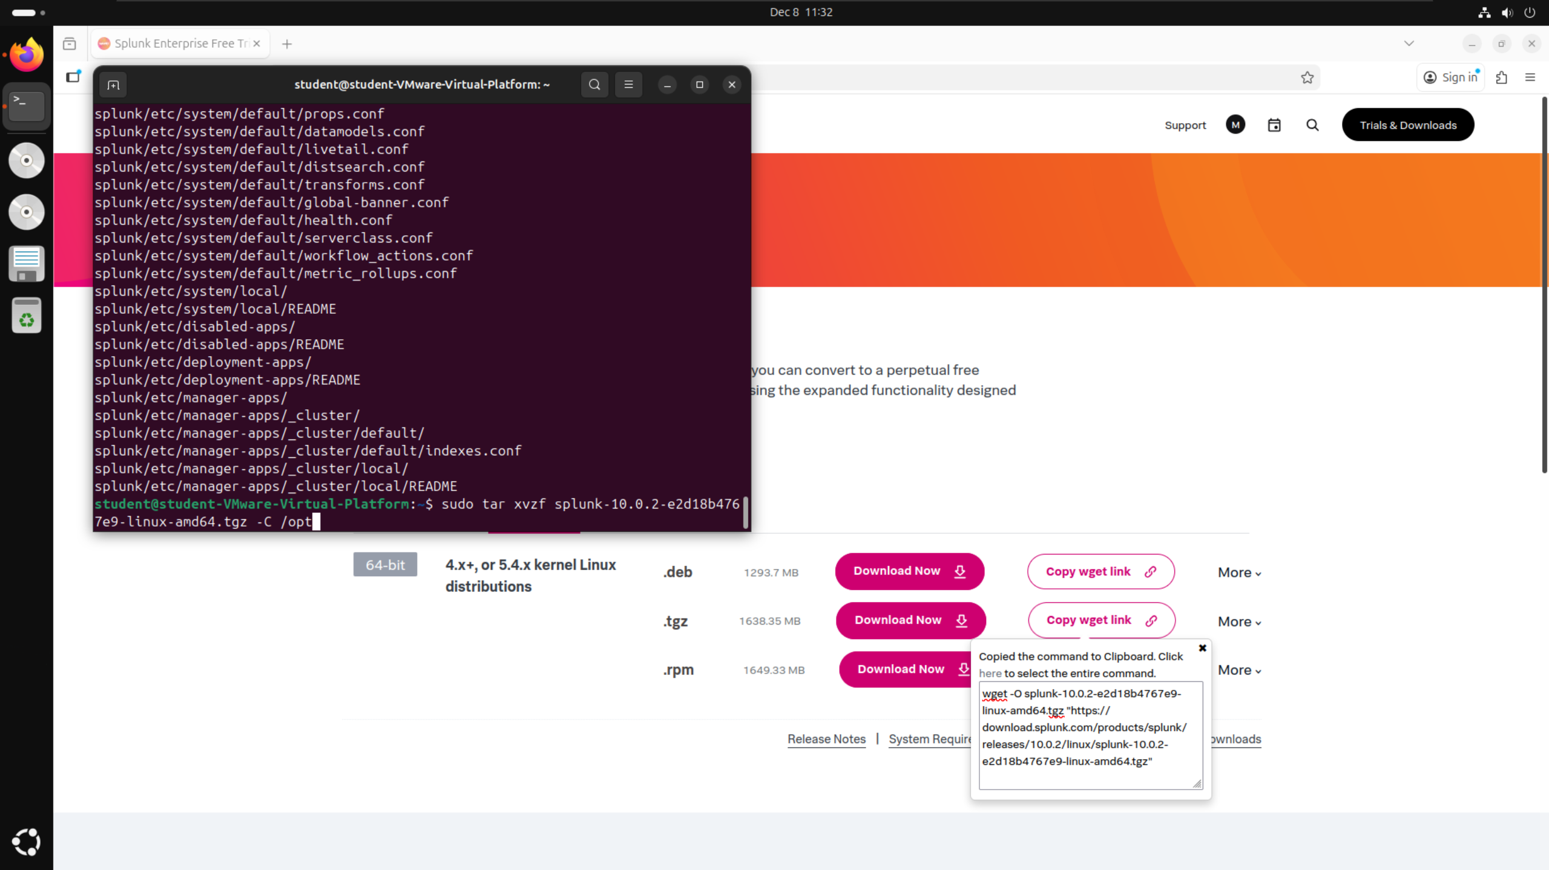

To start Splunk, I ran the command “sudo ./splunk start” from within the “/opt/splunk/bin” folder. Since this was my first time running Splunk on this installation, I had to also include the command “--accept-license” after which accepted the user license agreement for Splunk. Additionally, I had to set a username and password for the administrator account which I could then use to sign in once on localhost:8000.

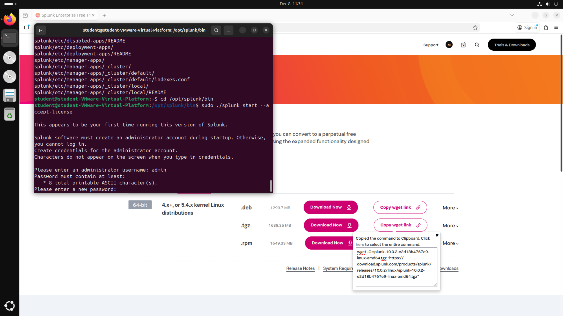

After setting up the initial login details, Splunk generated the web server on localhost:8000, providing a clickable link to the website to allow access into Splunk.

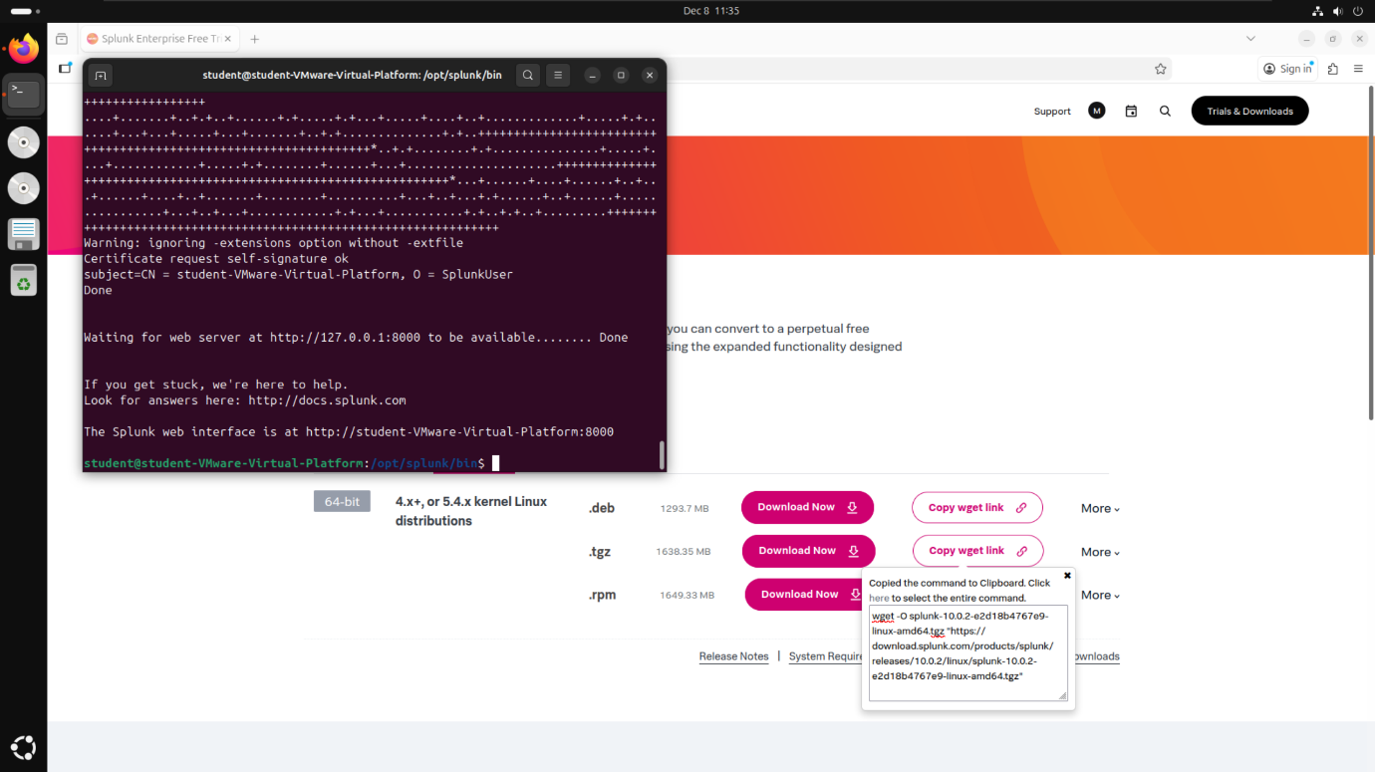

Either clicking on the link in the terminal or searching for localhost:8000 on Firefox took me to the Splunk enterprise login page. This is where I then entered the username and password I created in the previous step after starting Splunk for the first time.

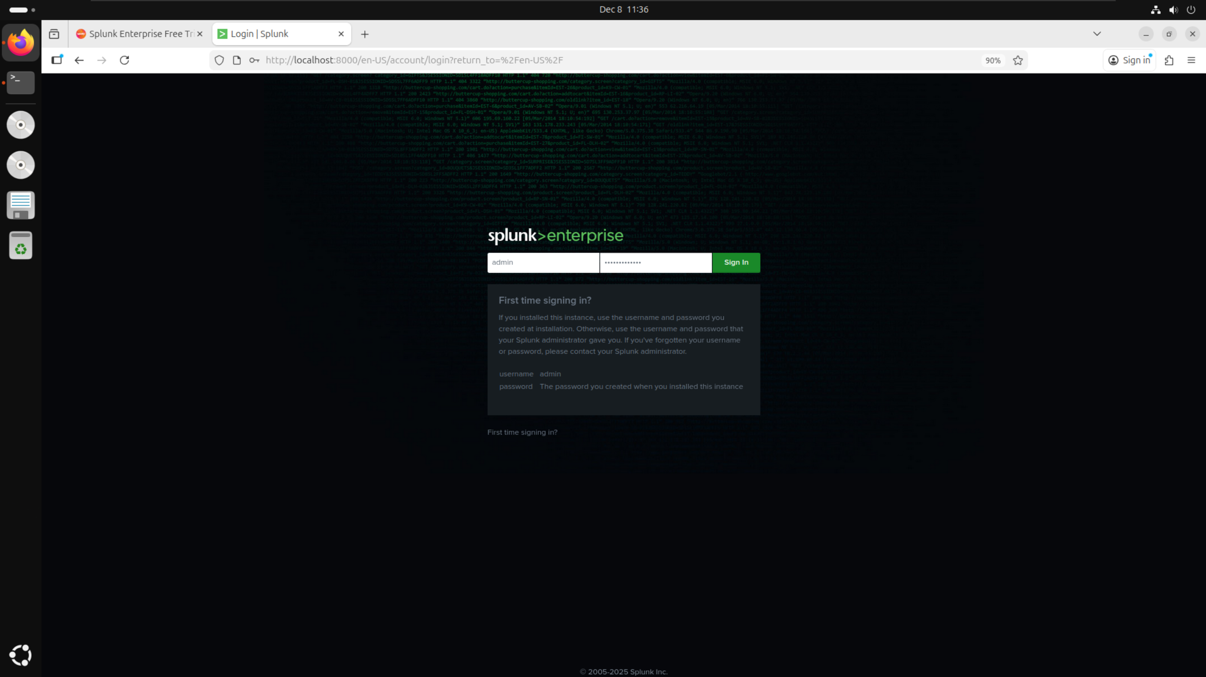

Once logged in, I was able to see the dashboard which houses all of the features which I used to answer the guided questions, most notably the “Search & Reporting” tab, which will be explained below.

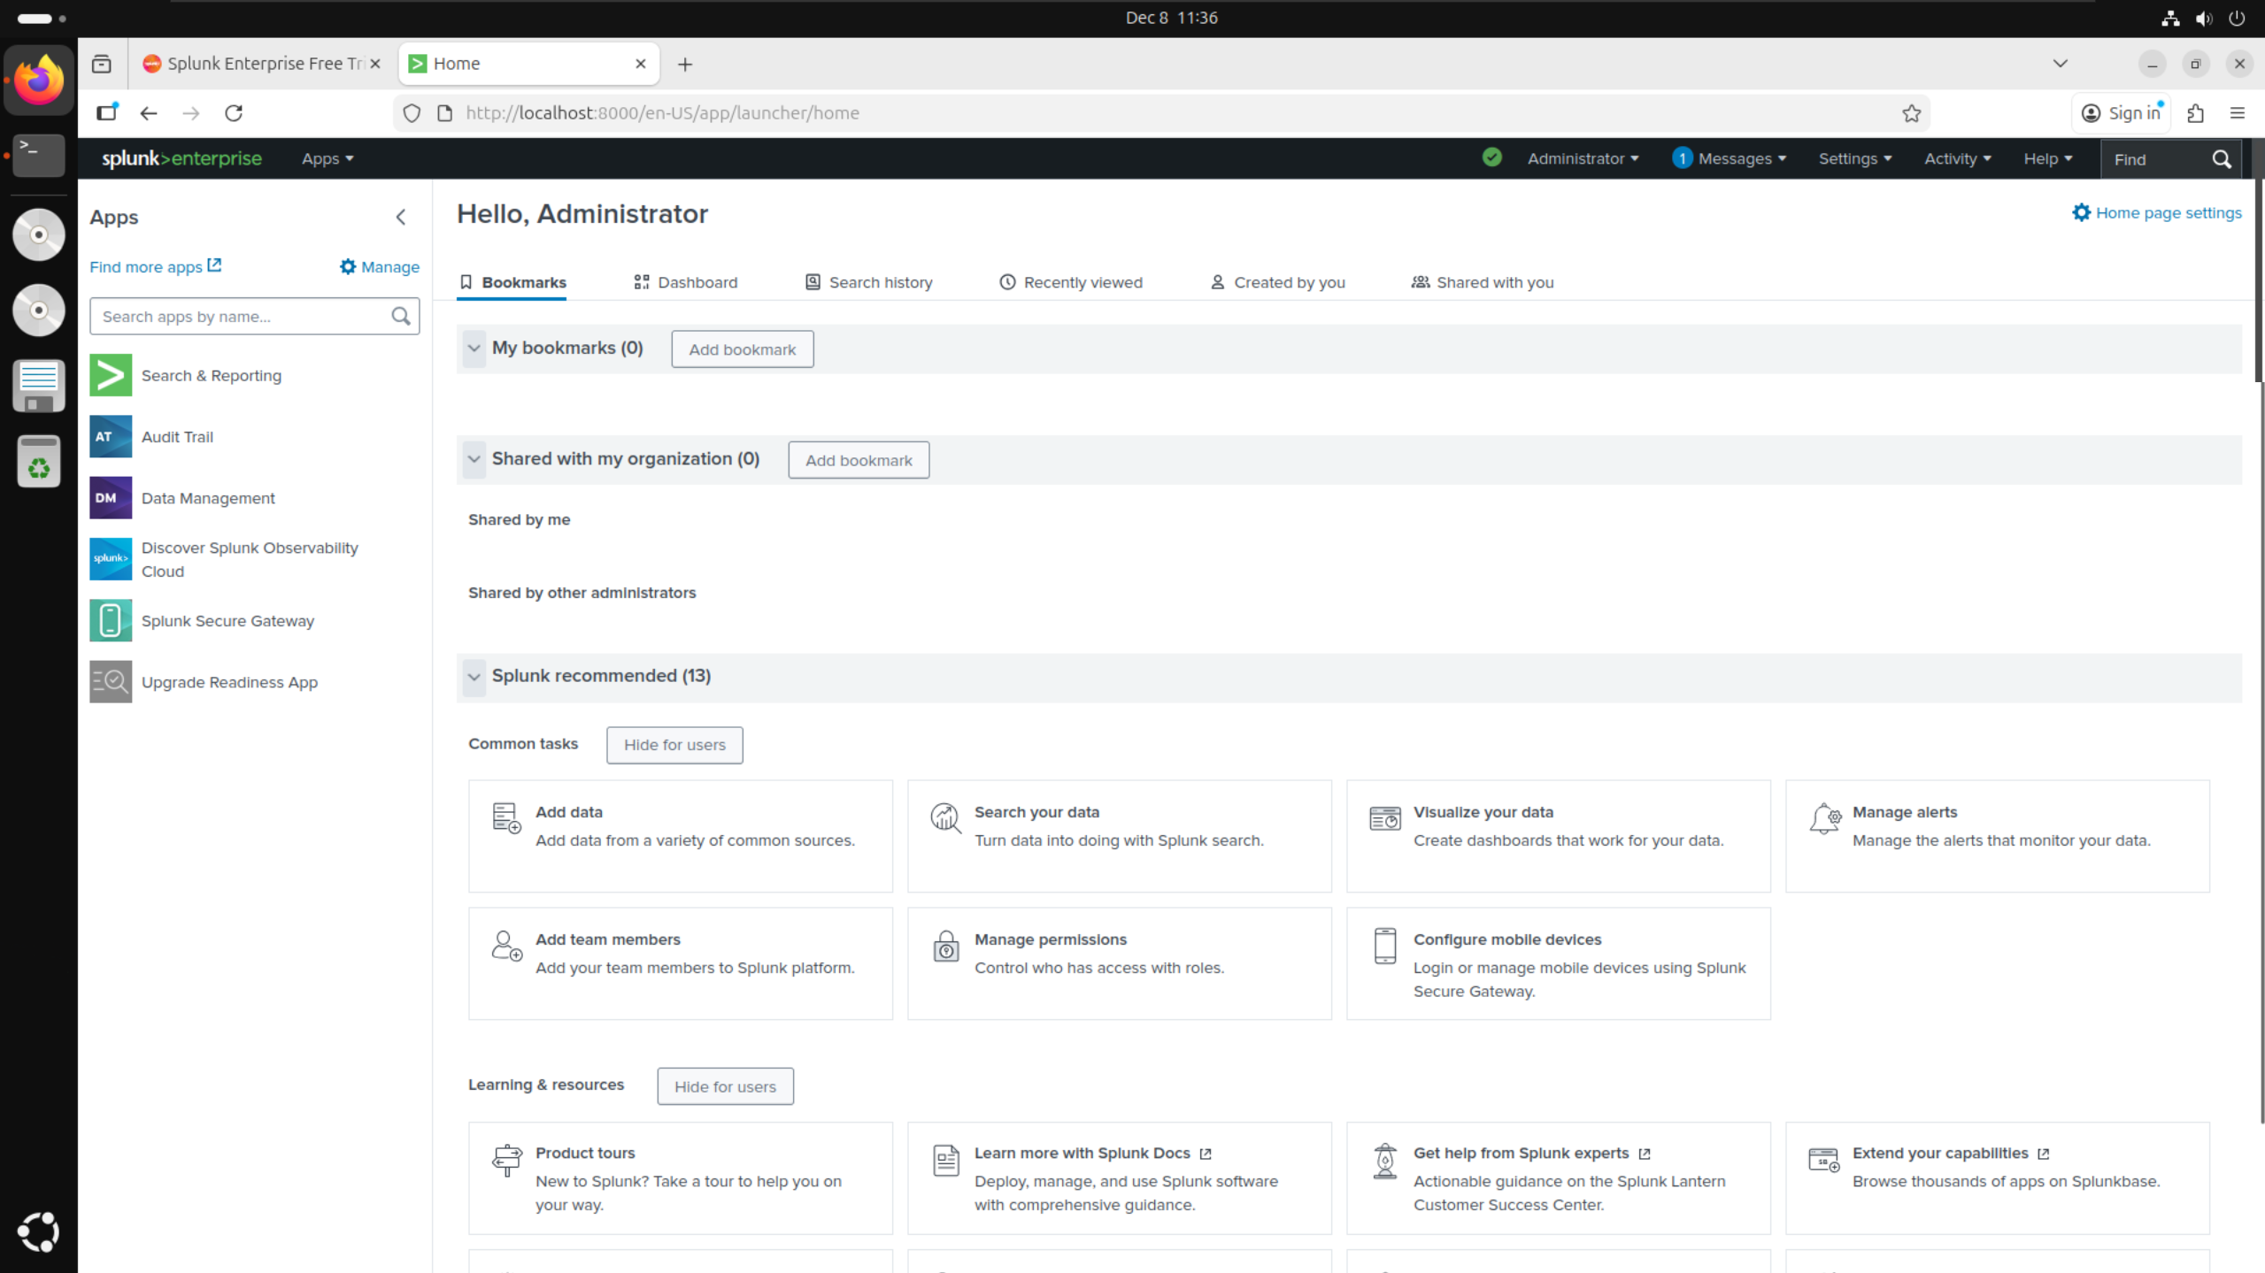

## BOTSv3 Dataset Preparation:

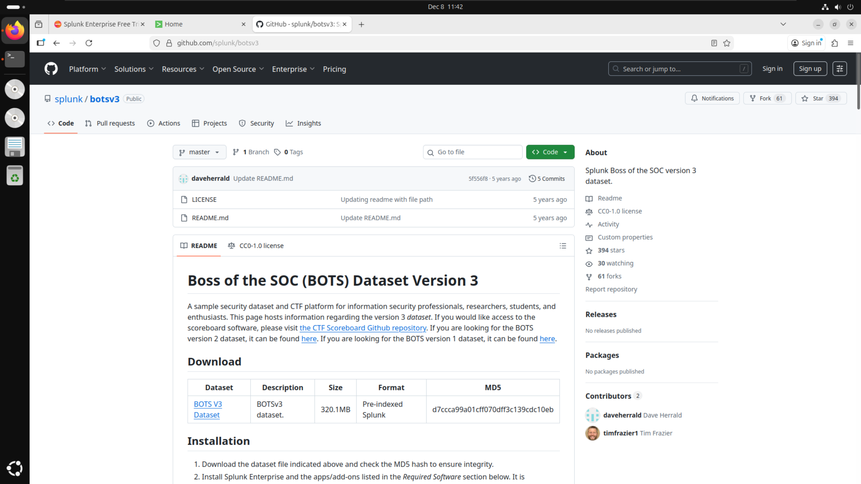

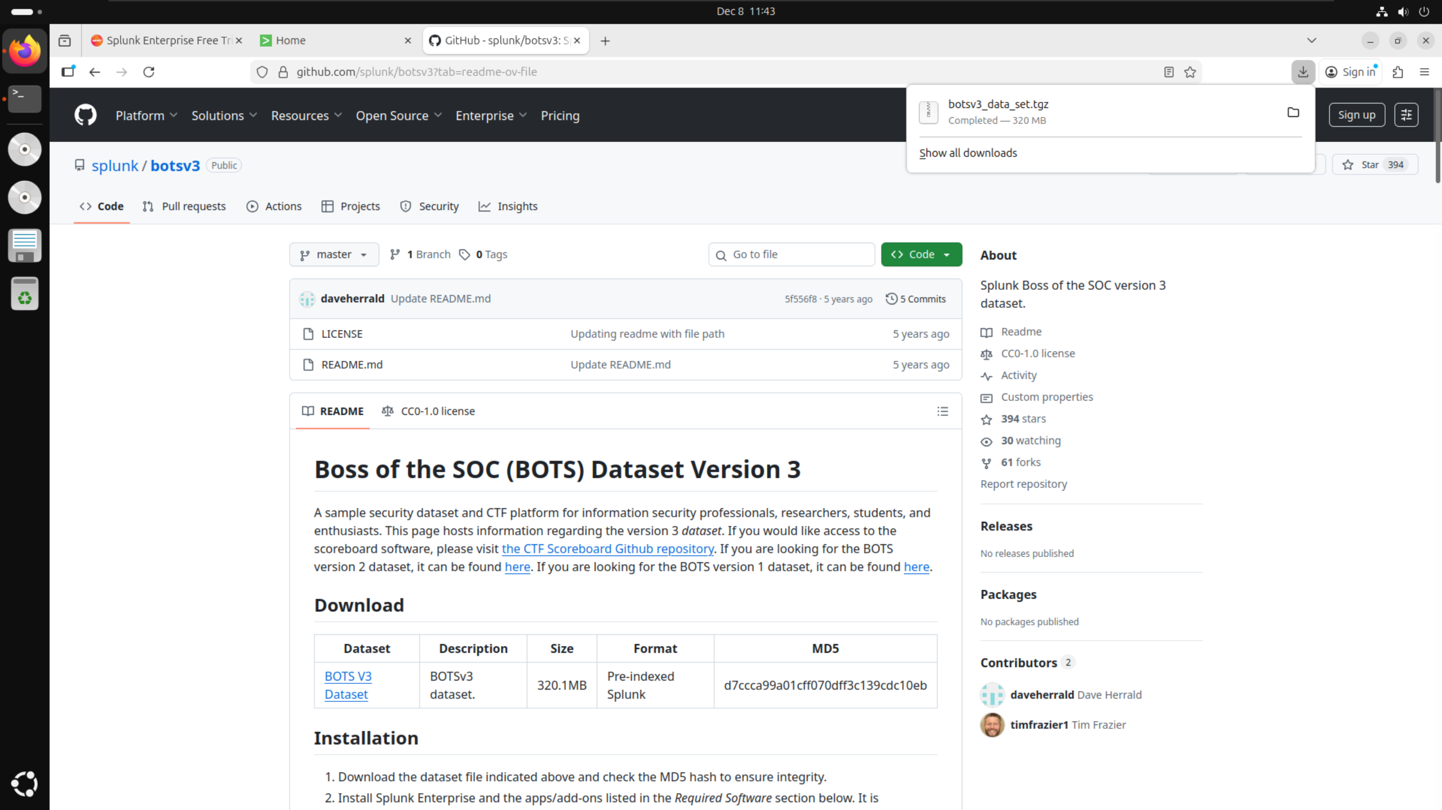

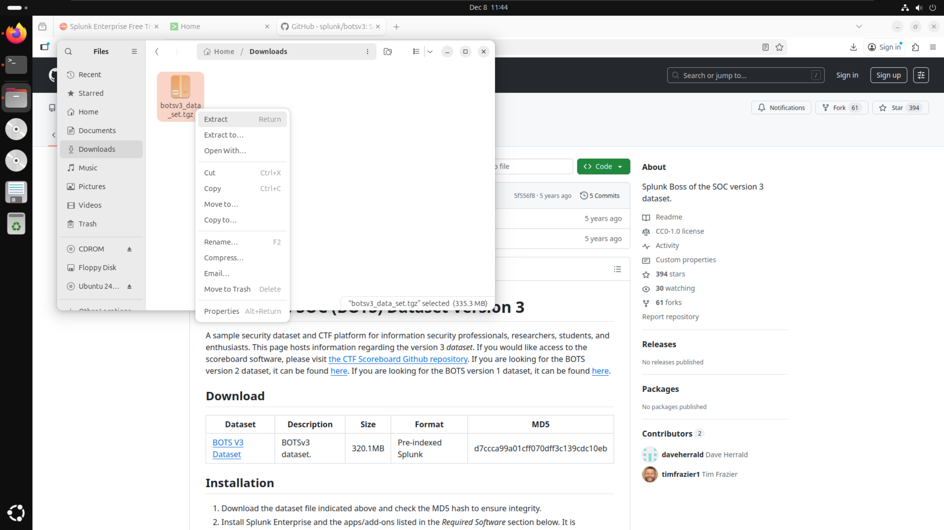

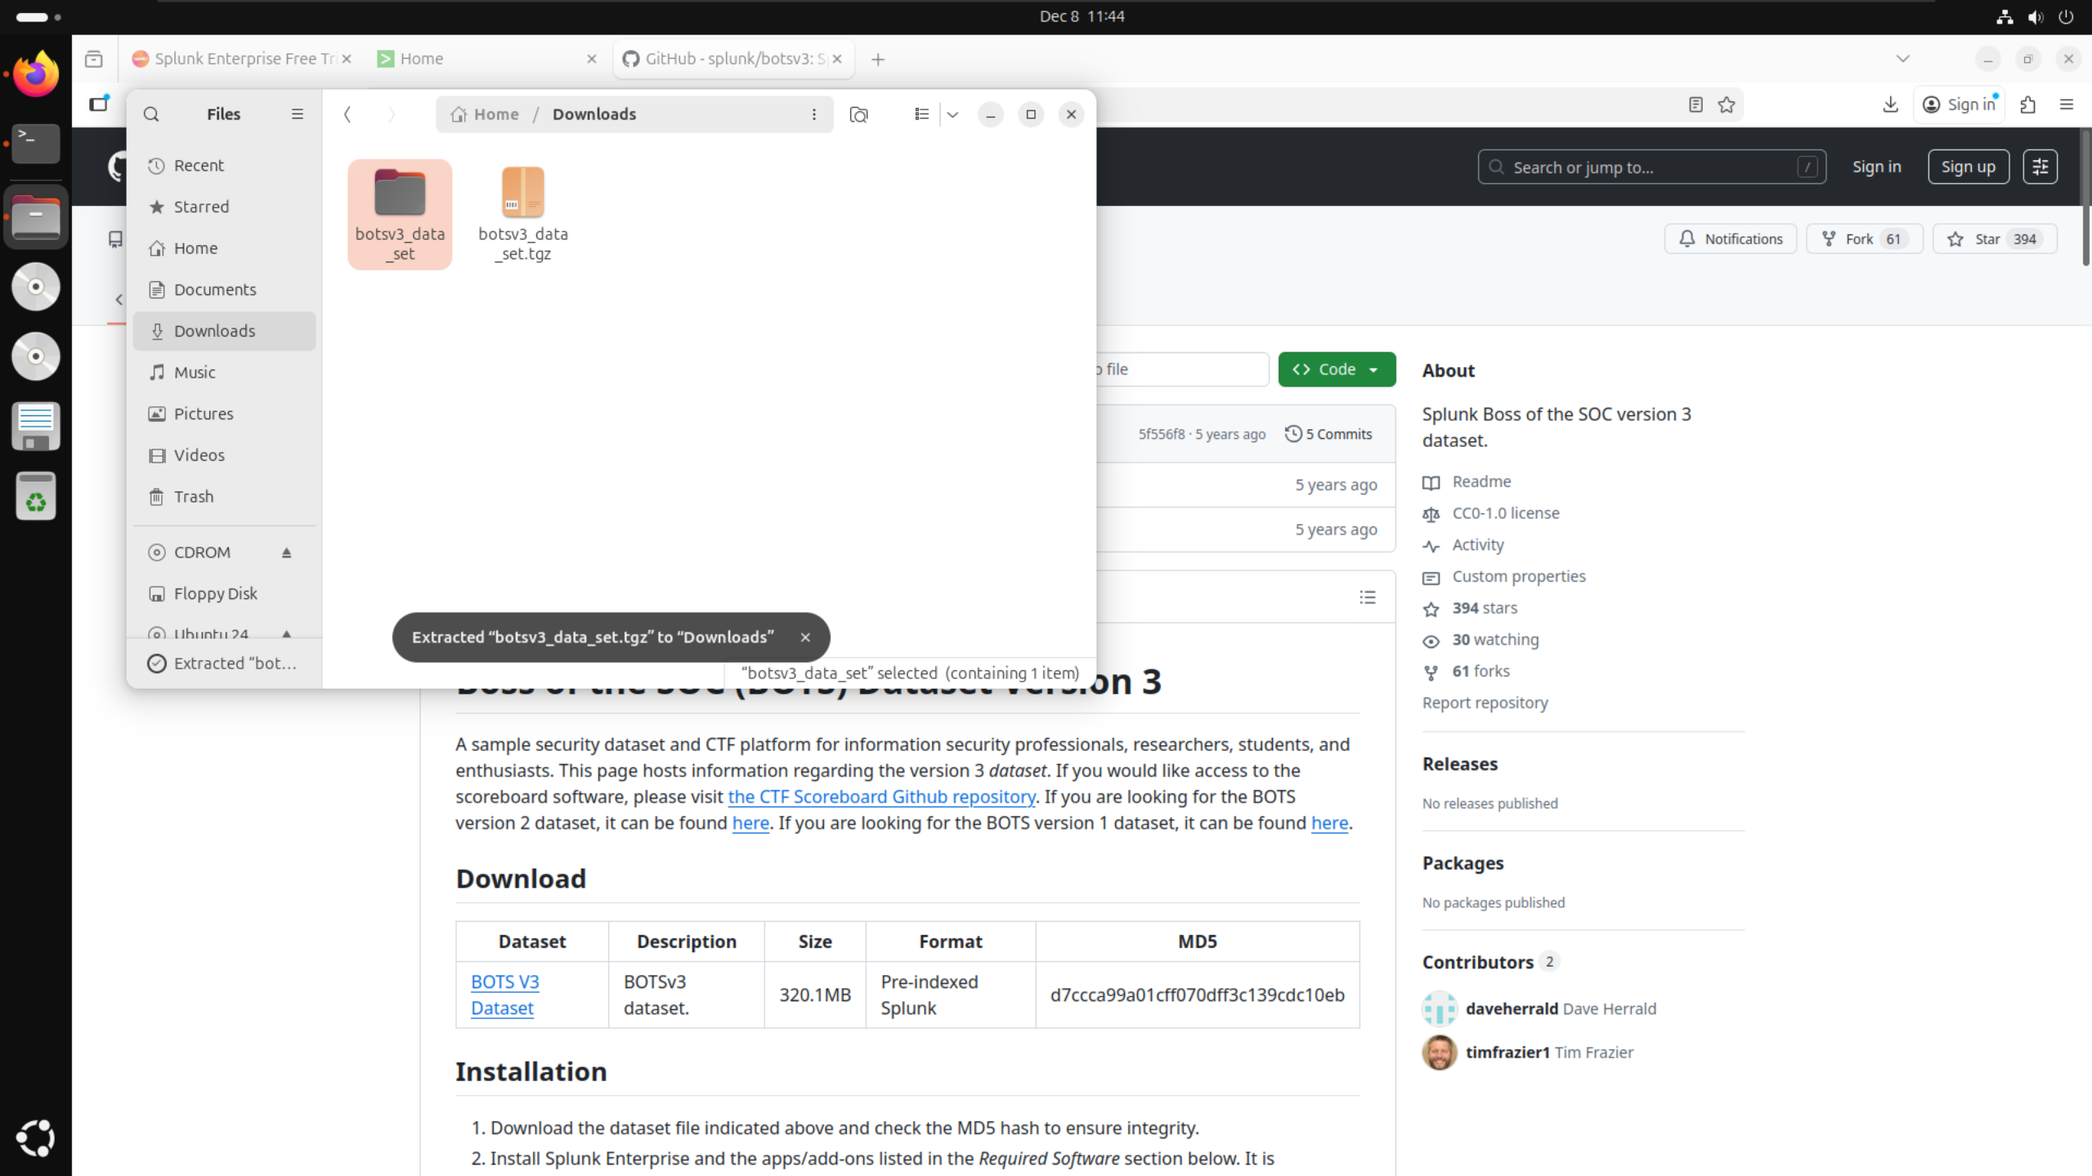

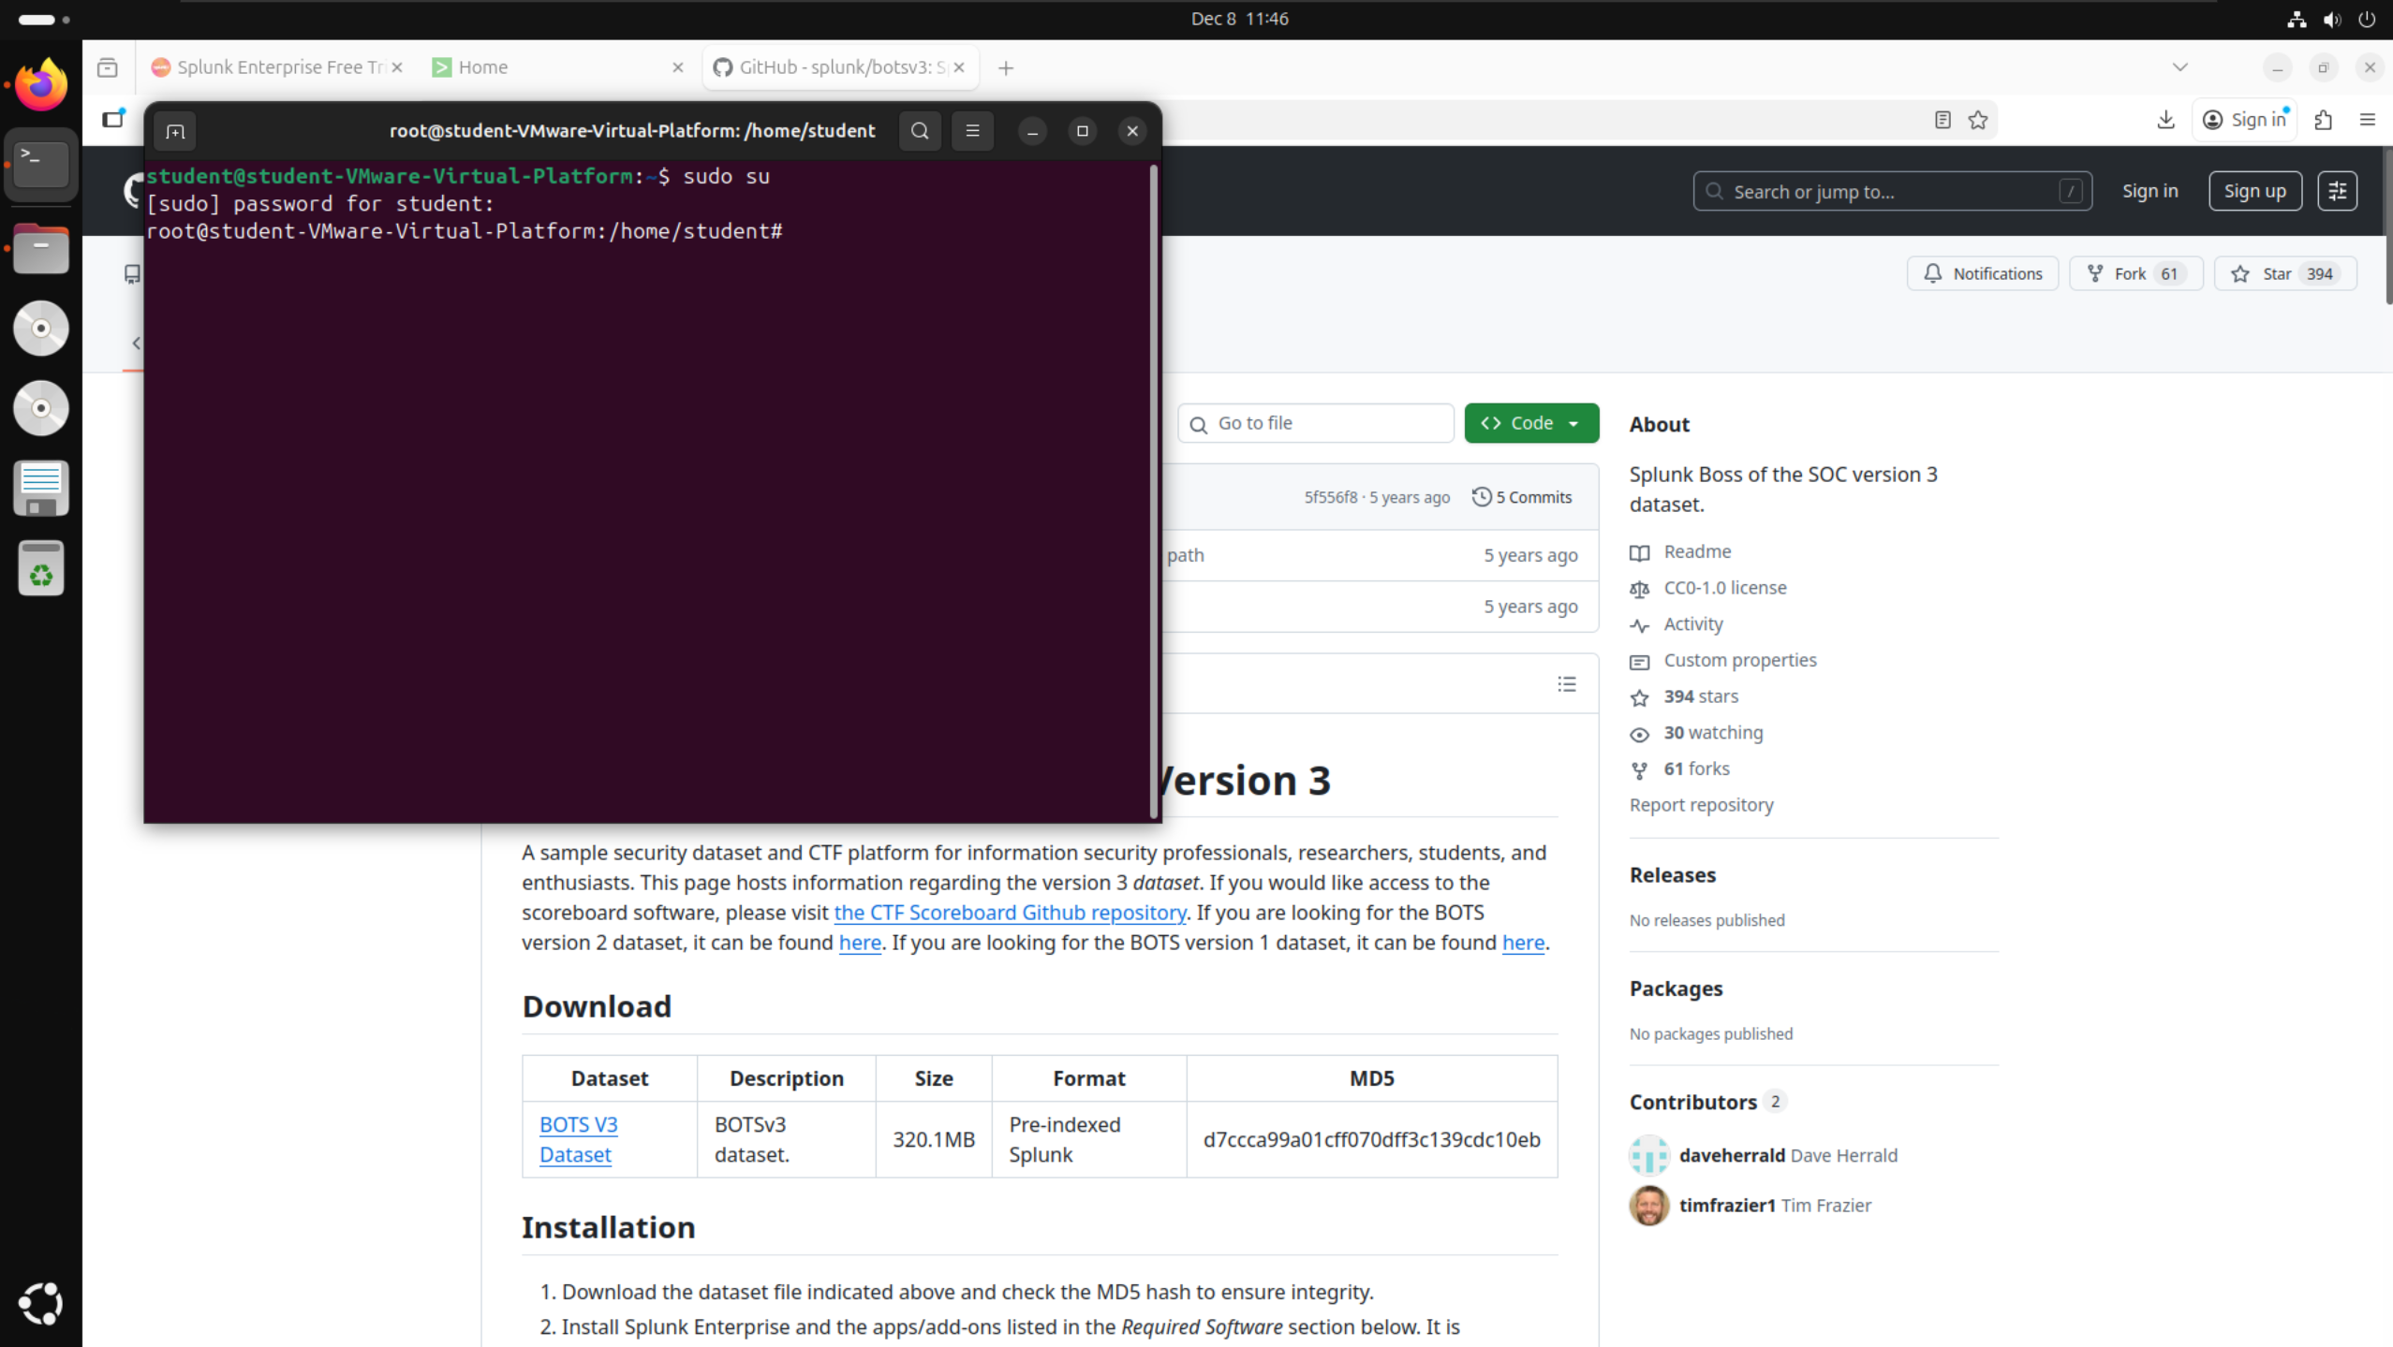

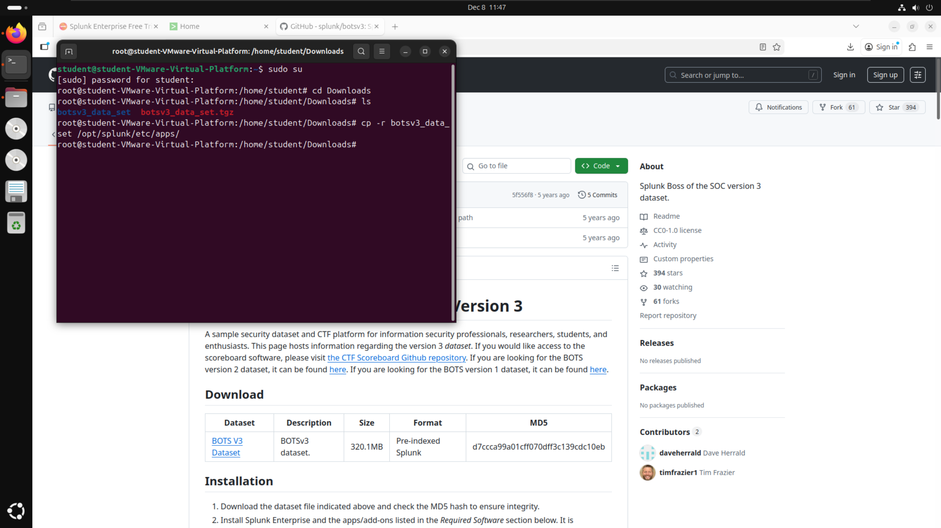

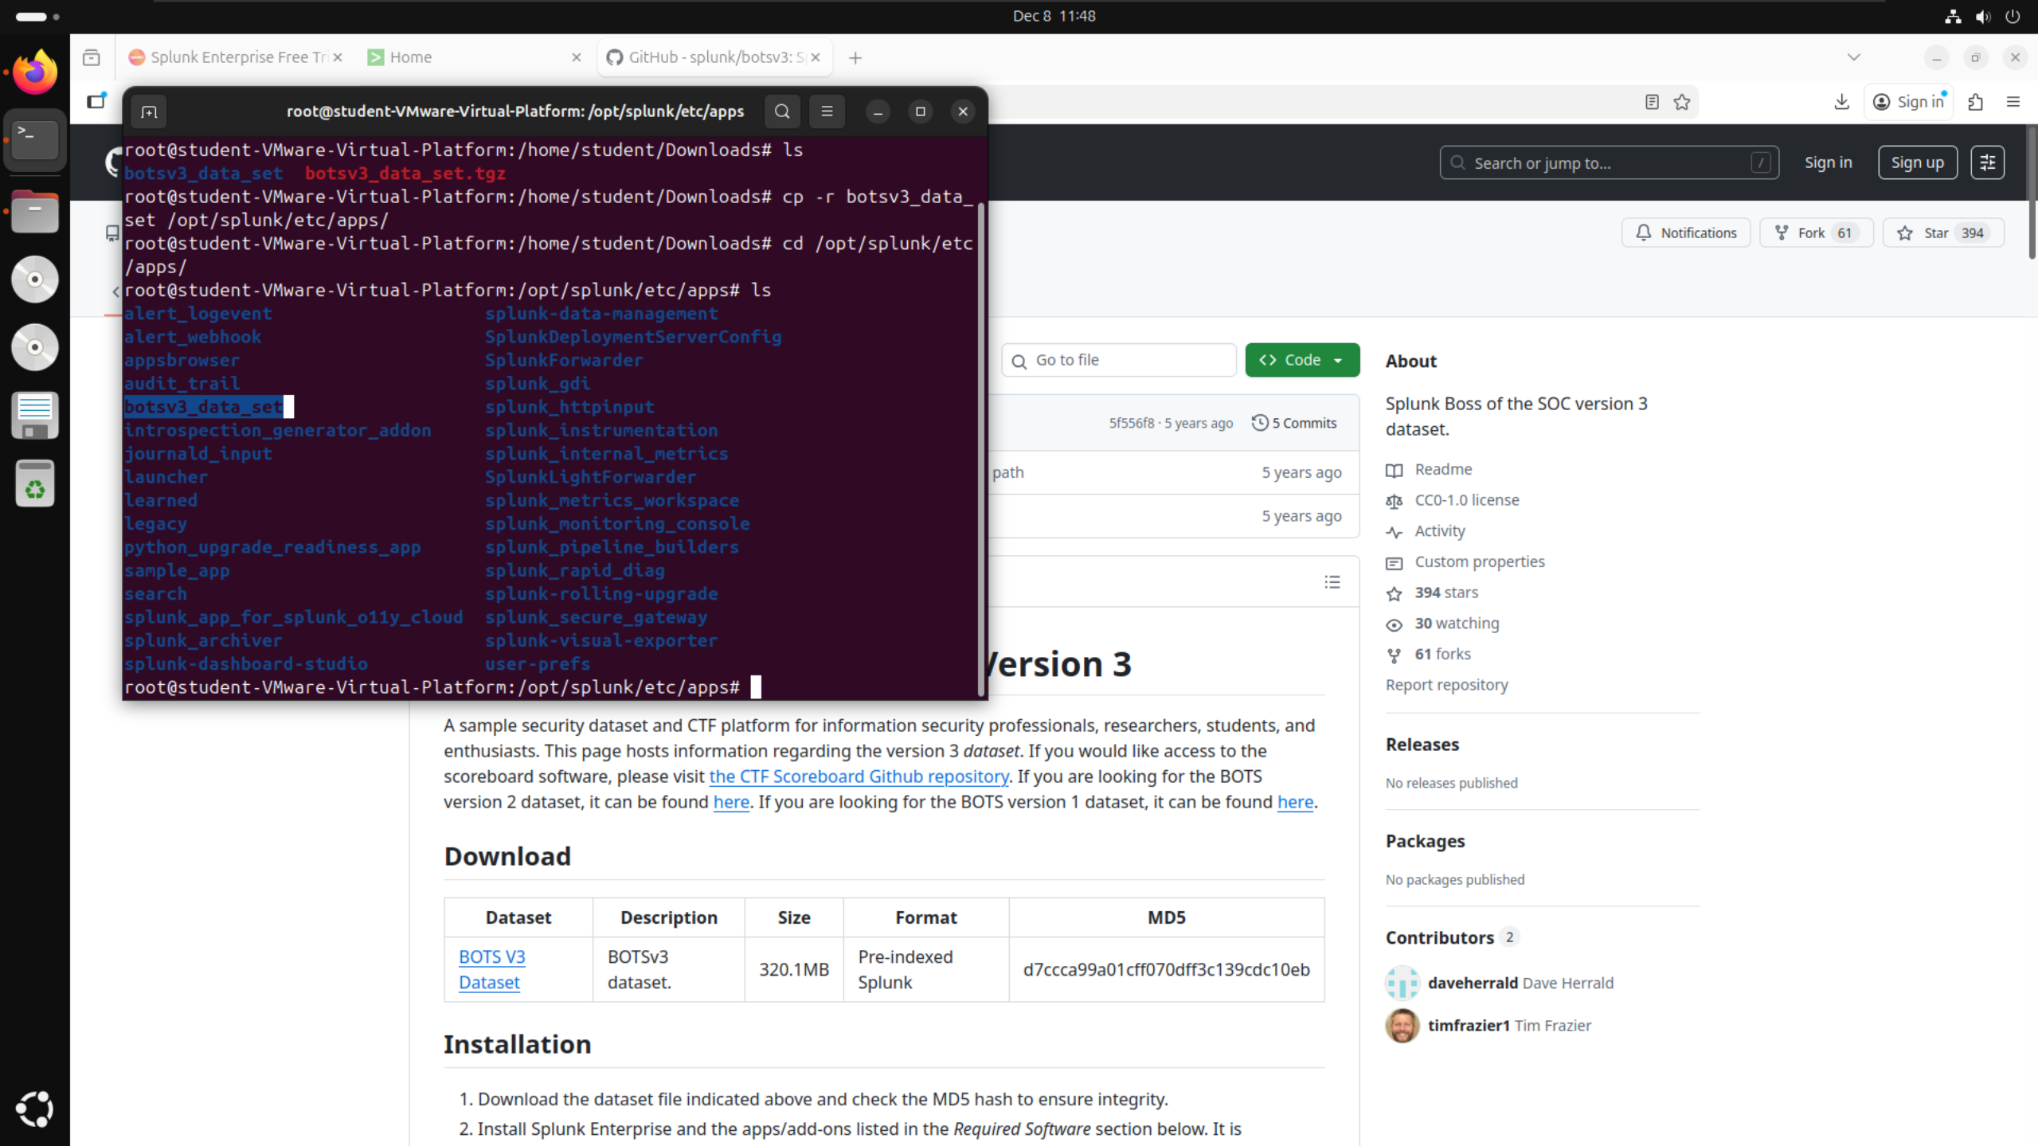

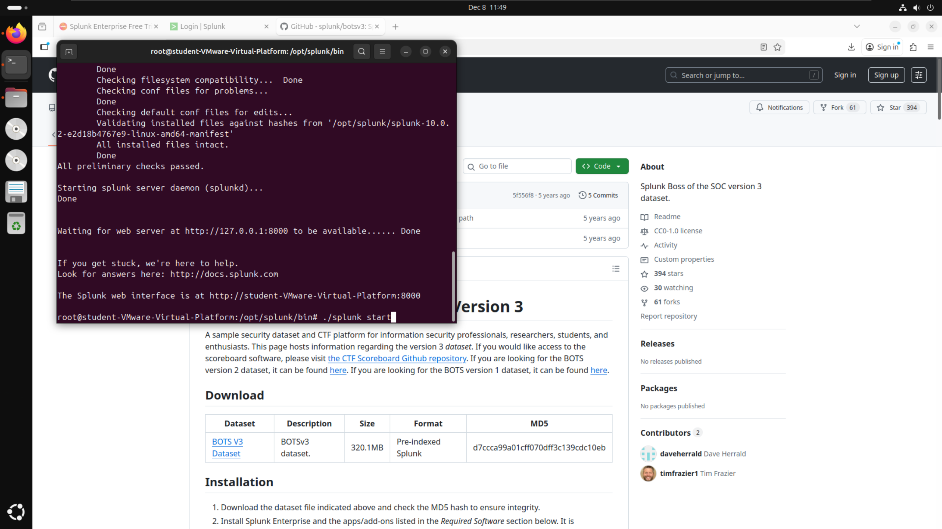

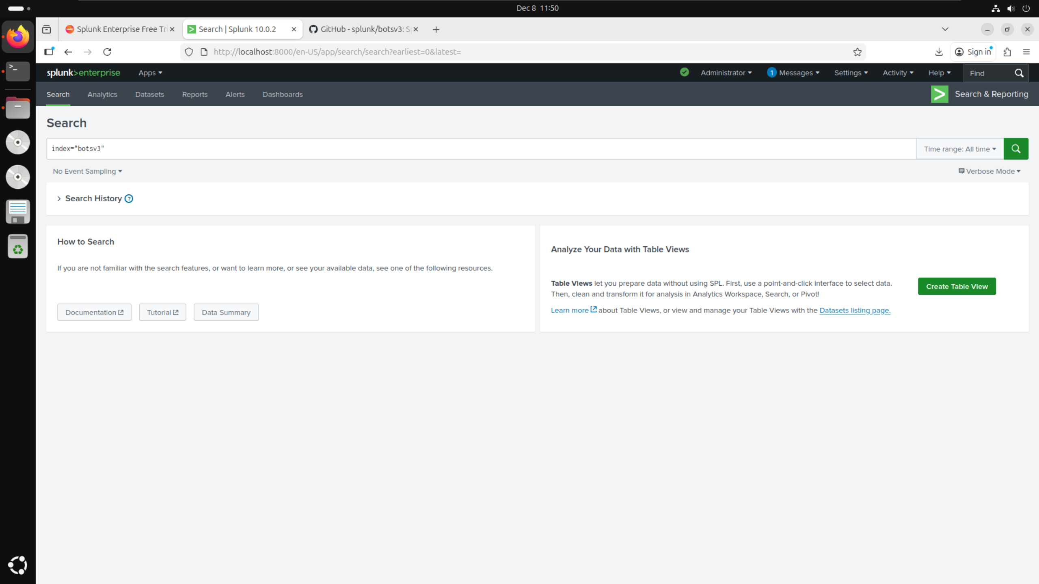

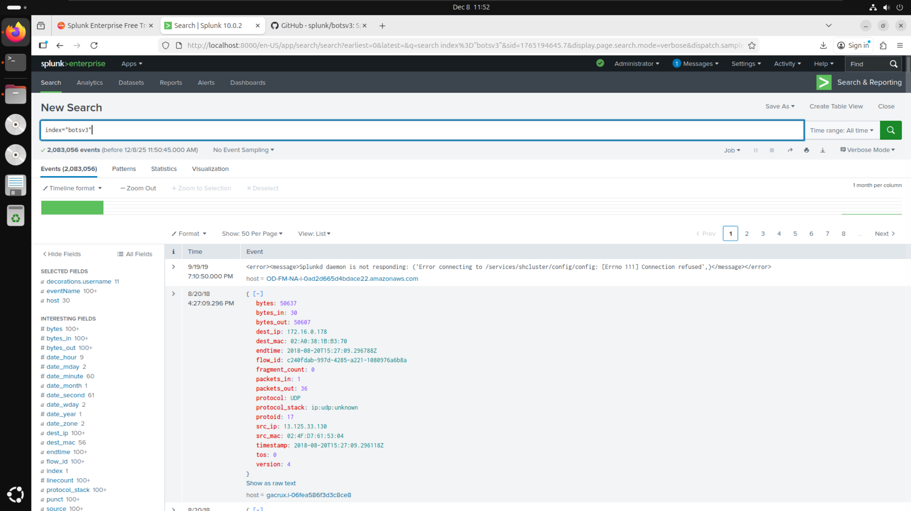

# Guided Questions:

## Question 1:

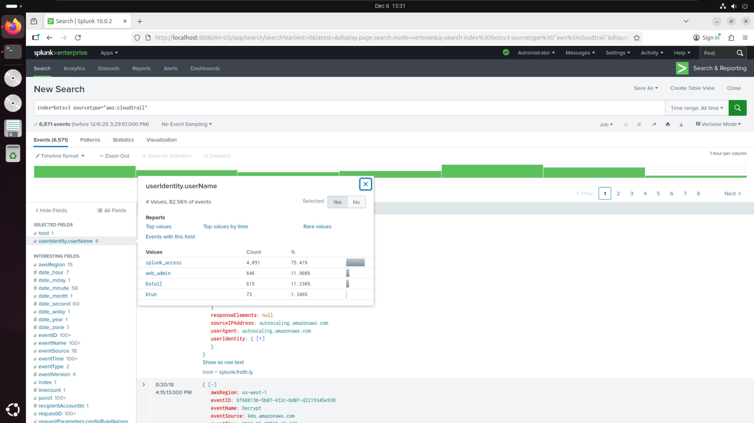

* Filtered BOTSv3 by sourcetype=”aws:cloudtrail” as given in the hints on the DLE quiz
* Searched within the filters for “username” and found userIdentity.userName filter
* Selected filter and checked values to find 4 names
* In alphabetical order: bstoll, btun, splunk_access, web_admin

## Question 2:

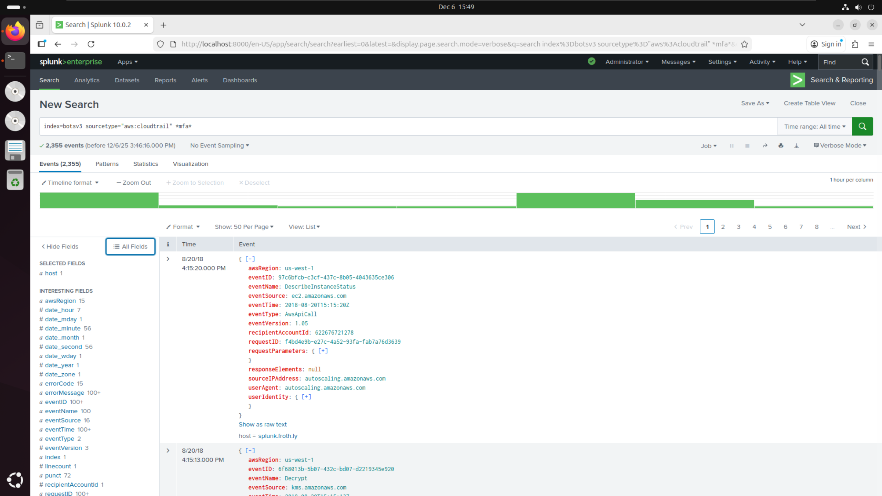

* Filtered BOTSv3 by sourcetype=”aws:cloudtrail” as given in the hints on the DLE quiz
* Added additional filter for *mfa* since looking for details relating to multi-factor authentication (using asterisks as given in the hints on the DLE quiz)

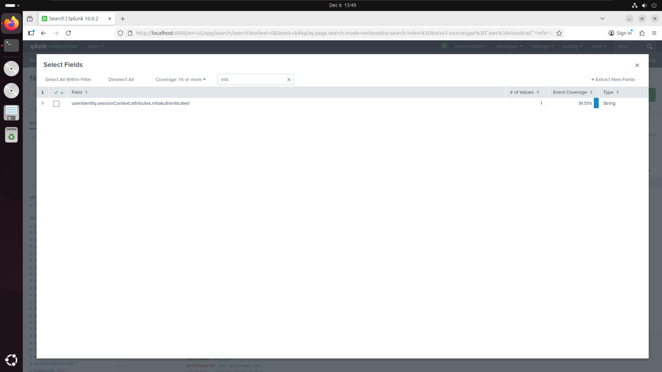

* Searched additional filters for anything related to “mfa” to find userIdentity.sessionContext.attributes.mfaAuthenticated

## Question 3:

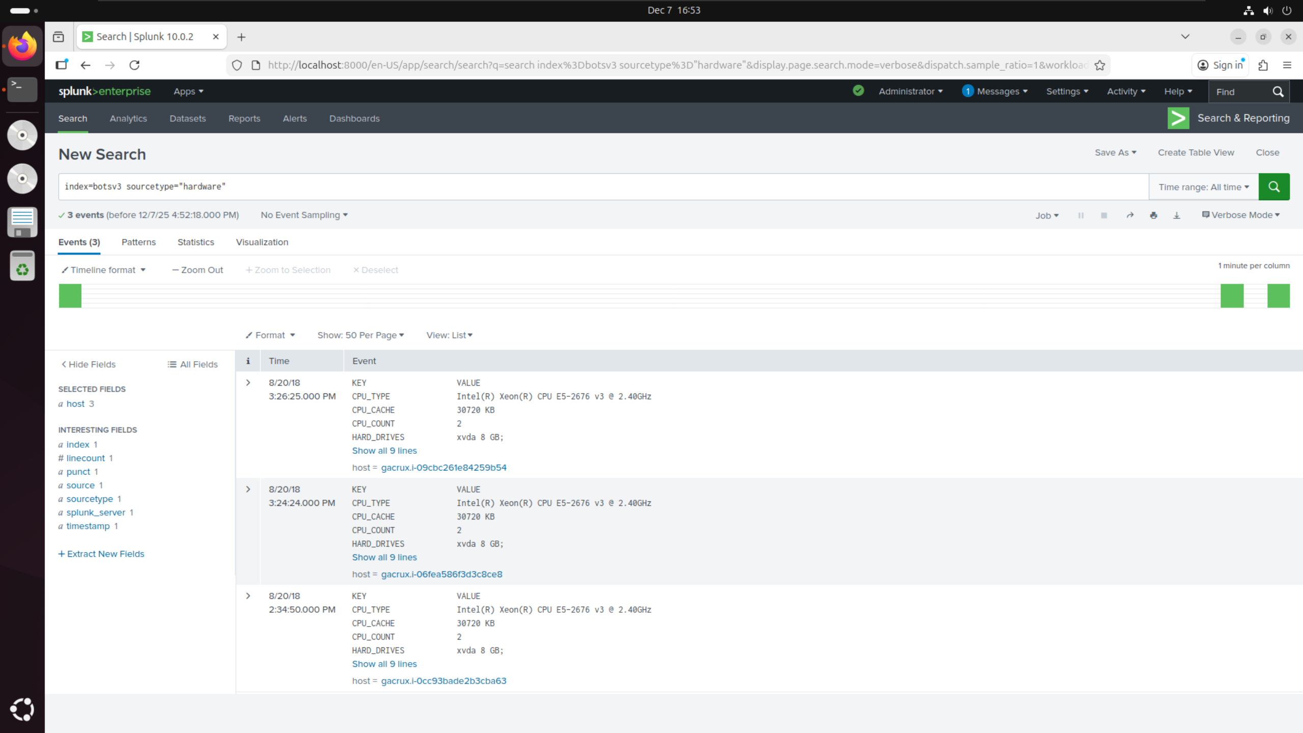

* Filtered BOTSv3 by sourcetype=”hardware” as given in the hints on the DLE quiz
* Checked value of CPU_TYPE and found the model number of E5-2676 in the correct form of **-**** given in the hints on the DLE quiz

## Question 4:

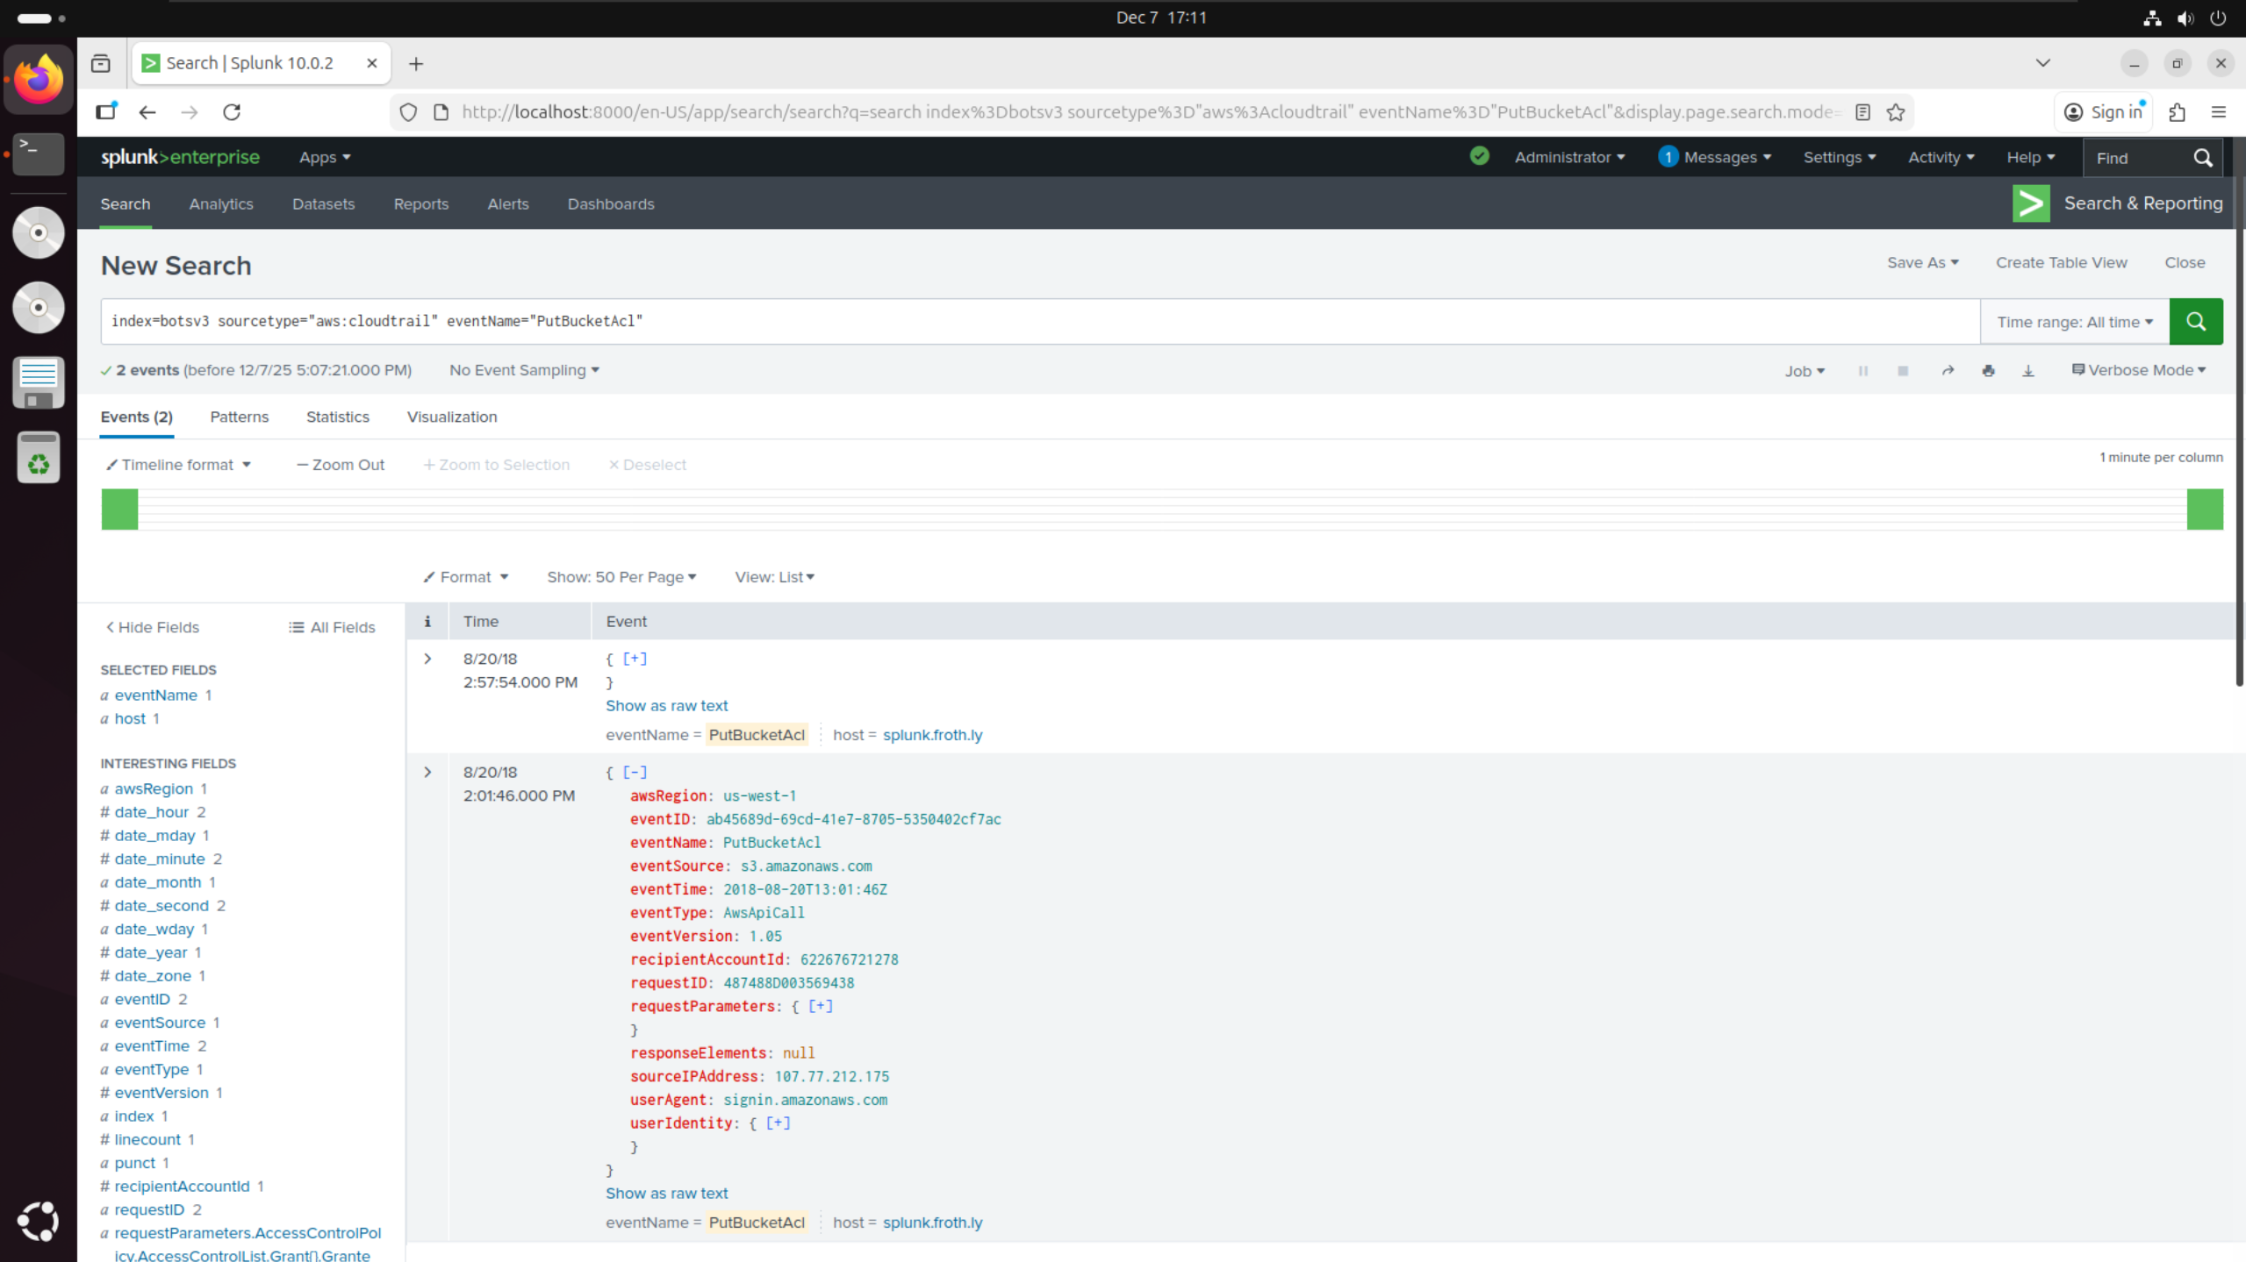

* Filtered BOTSv3 by sourcetype=”aws:cloudtrail” and specific eventName=”PutBucketAcl” as given in the hints on the DLE quiz
* Noticed 2 events with this event name but different event IDs
* Assumed these events would be user accidentally making the S3 bucket public (older event) then making it private again (newer event) giving the correct eventID as ab45689d-69cd-41e7-8705-5350402cf7ac

## Question 5:

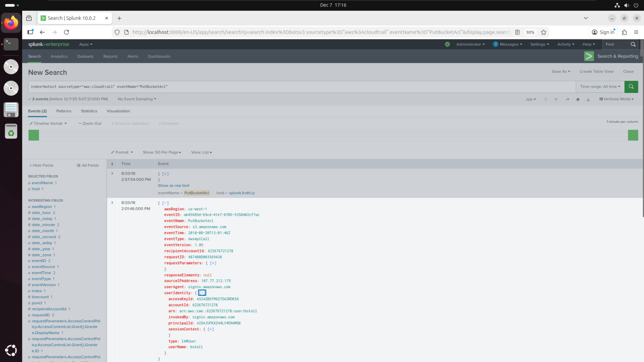

* Applied same filters as question 4
* Opened userIdentity field within the relevant event and found userName: bstoll

## Question 6:

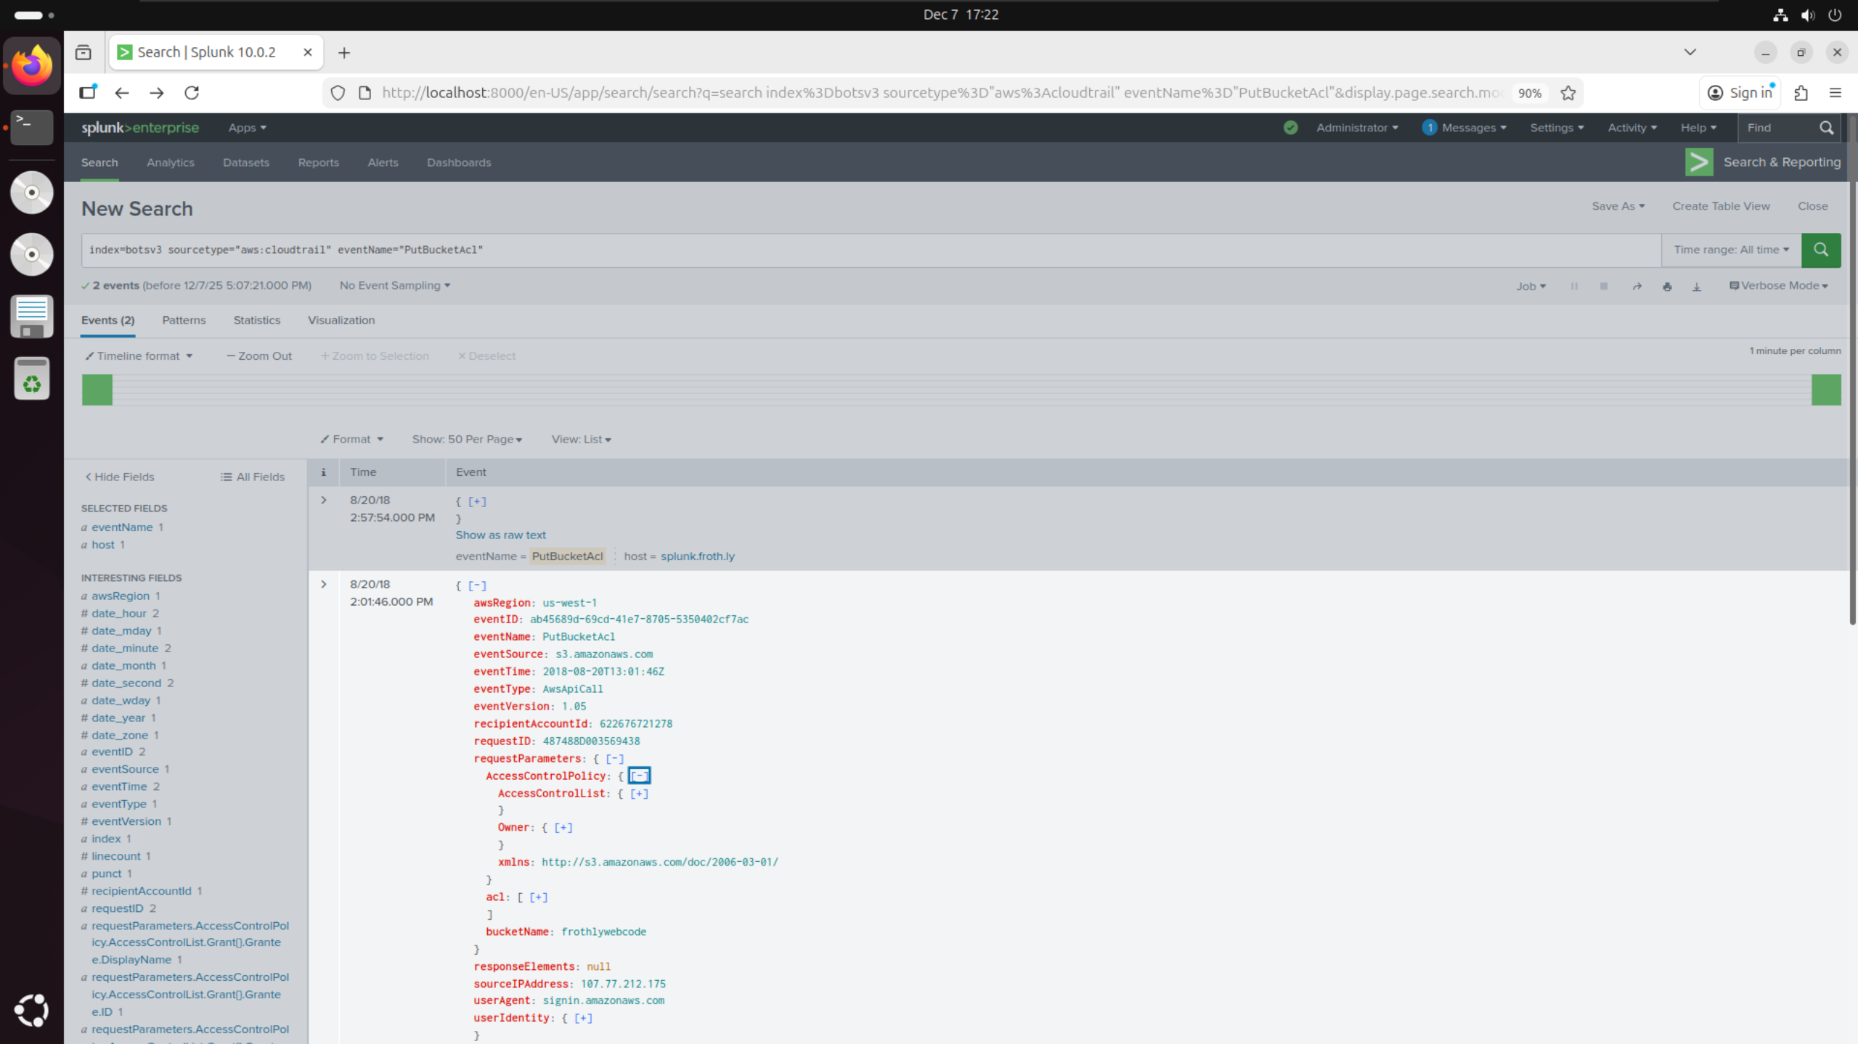

* Applied same filters as question 4
* Opened requestParameters field within the relevant event and found bucketName: frothlywebcode

## Question 7:

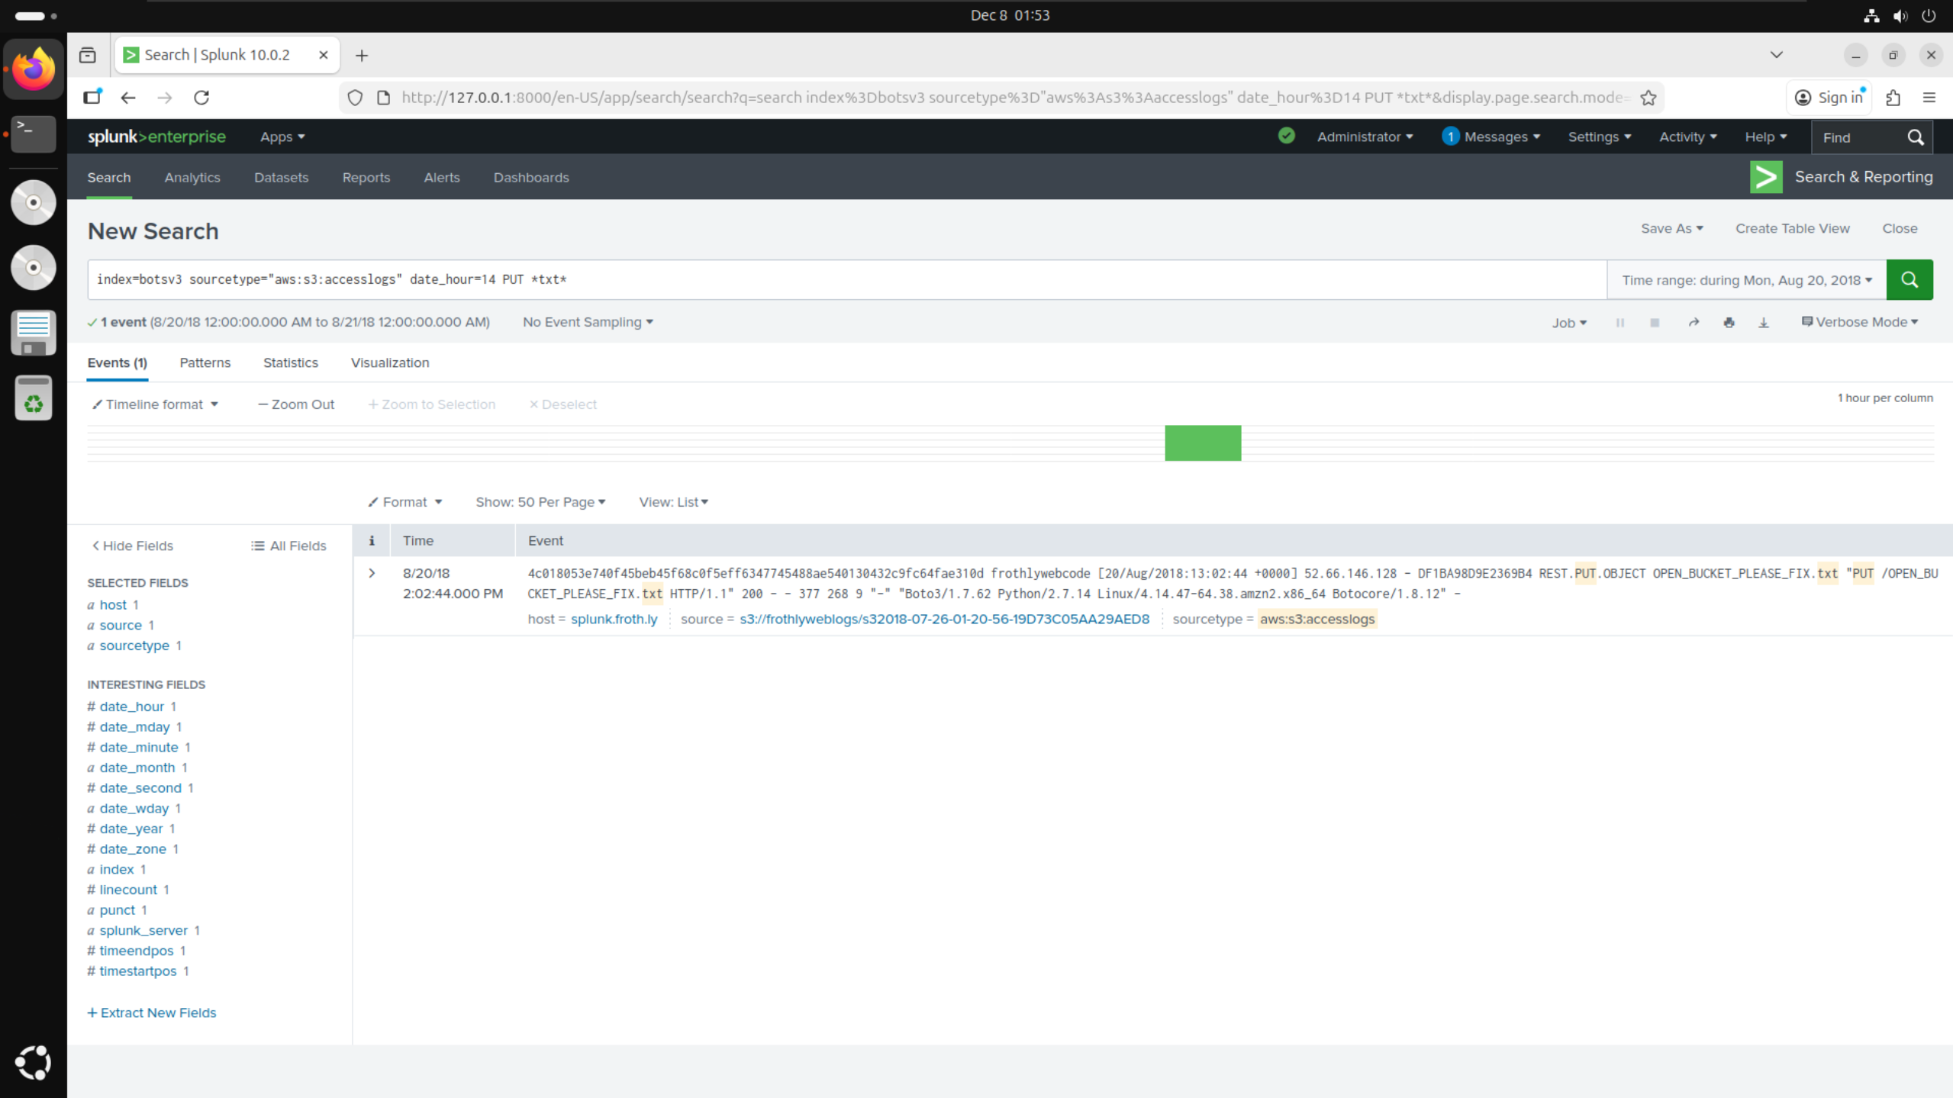

* Filtered BOTSv3 by sourcetype=”aws:s3:accesslogs” as given in the hints on the DLE quiz
* Filtered specifically for events at date_hour=14 since questions 4-6 show both events occur between 2pm
* Filtered for PUT requests as suggested by the question since this event involved uploading a file to the bucket
* Filtered for *txt* since the question asked for the name of the text file uploaded therefore hinting it would be a .txt extension

## Question 8:

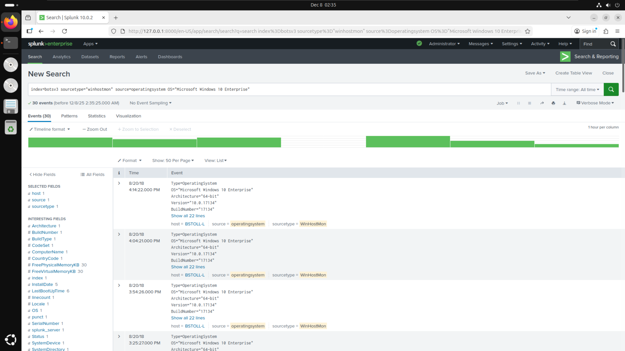

* Filtered BOTSv3 by sourcetype=”winhostmon” as given in the hints on the DLE quiz
* Searched though the filters list to find source filter and selected source=”operatingsystem” from the list
* Searched through the filters list again to find OS filter and selected OS=”Microsoft Windows 10 Enterprise” from the list as it had the least uses -> Was used 30 times by only one user

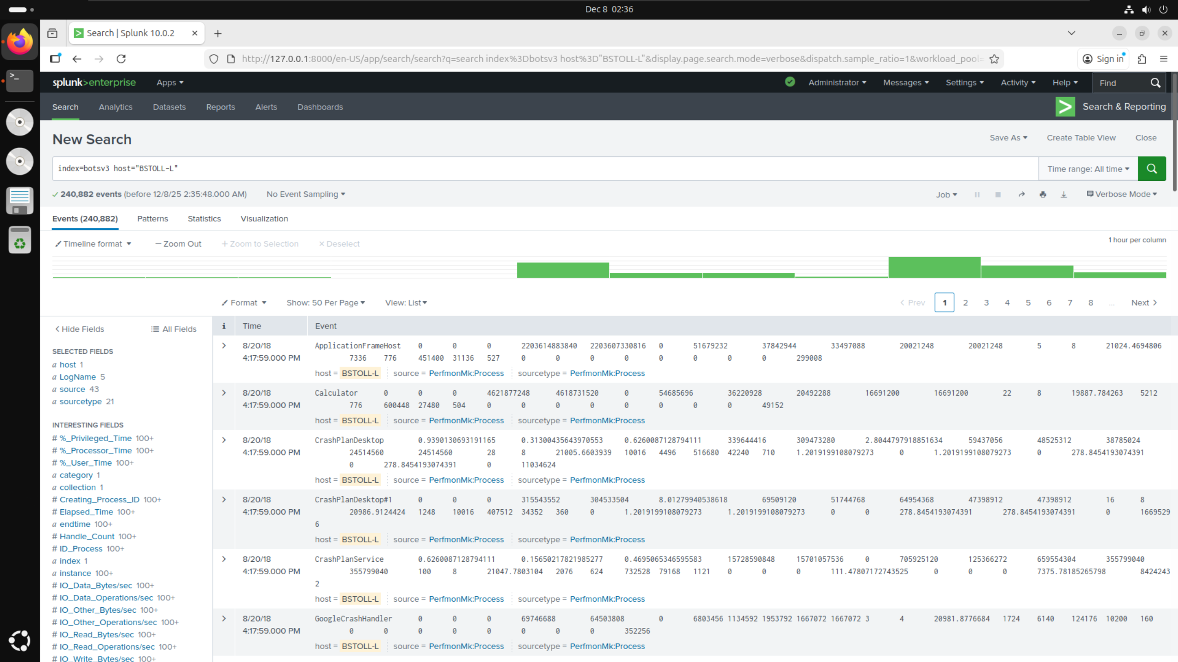

* Added host=”BSTOLL-L” from the initial search into a new search to look for any filters with the FQDN

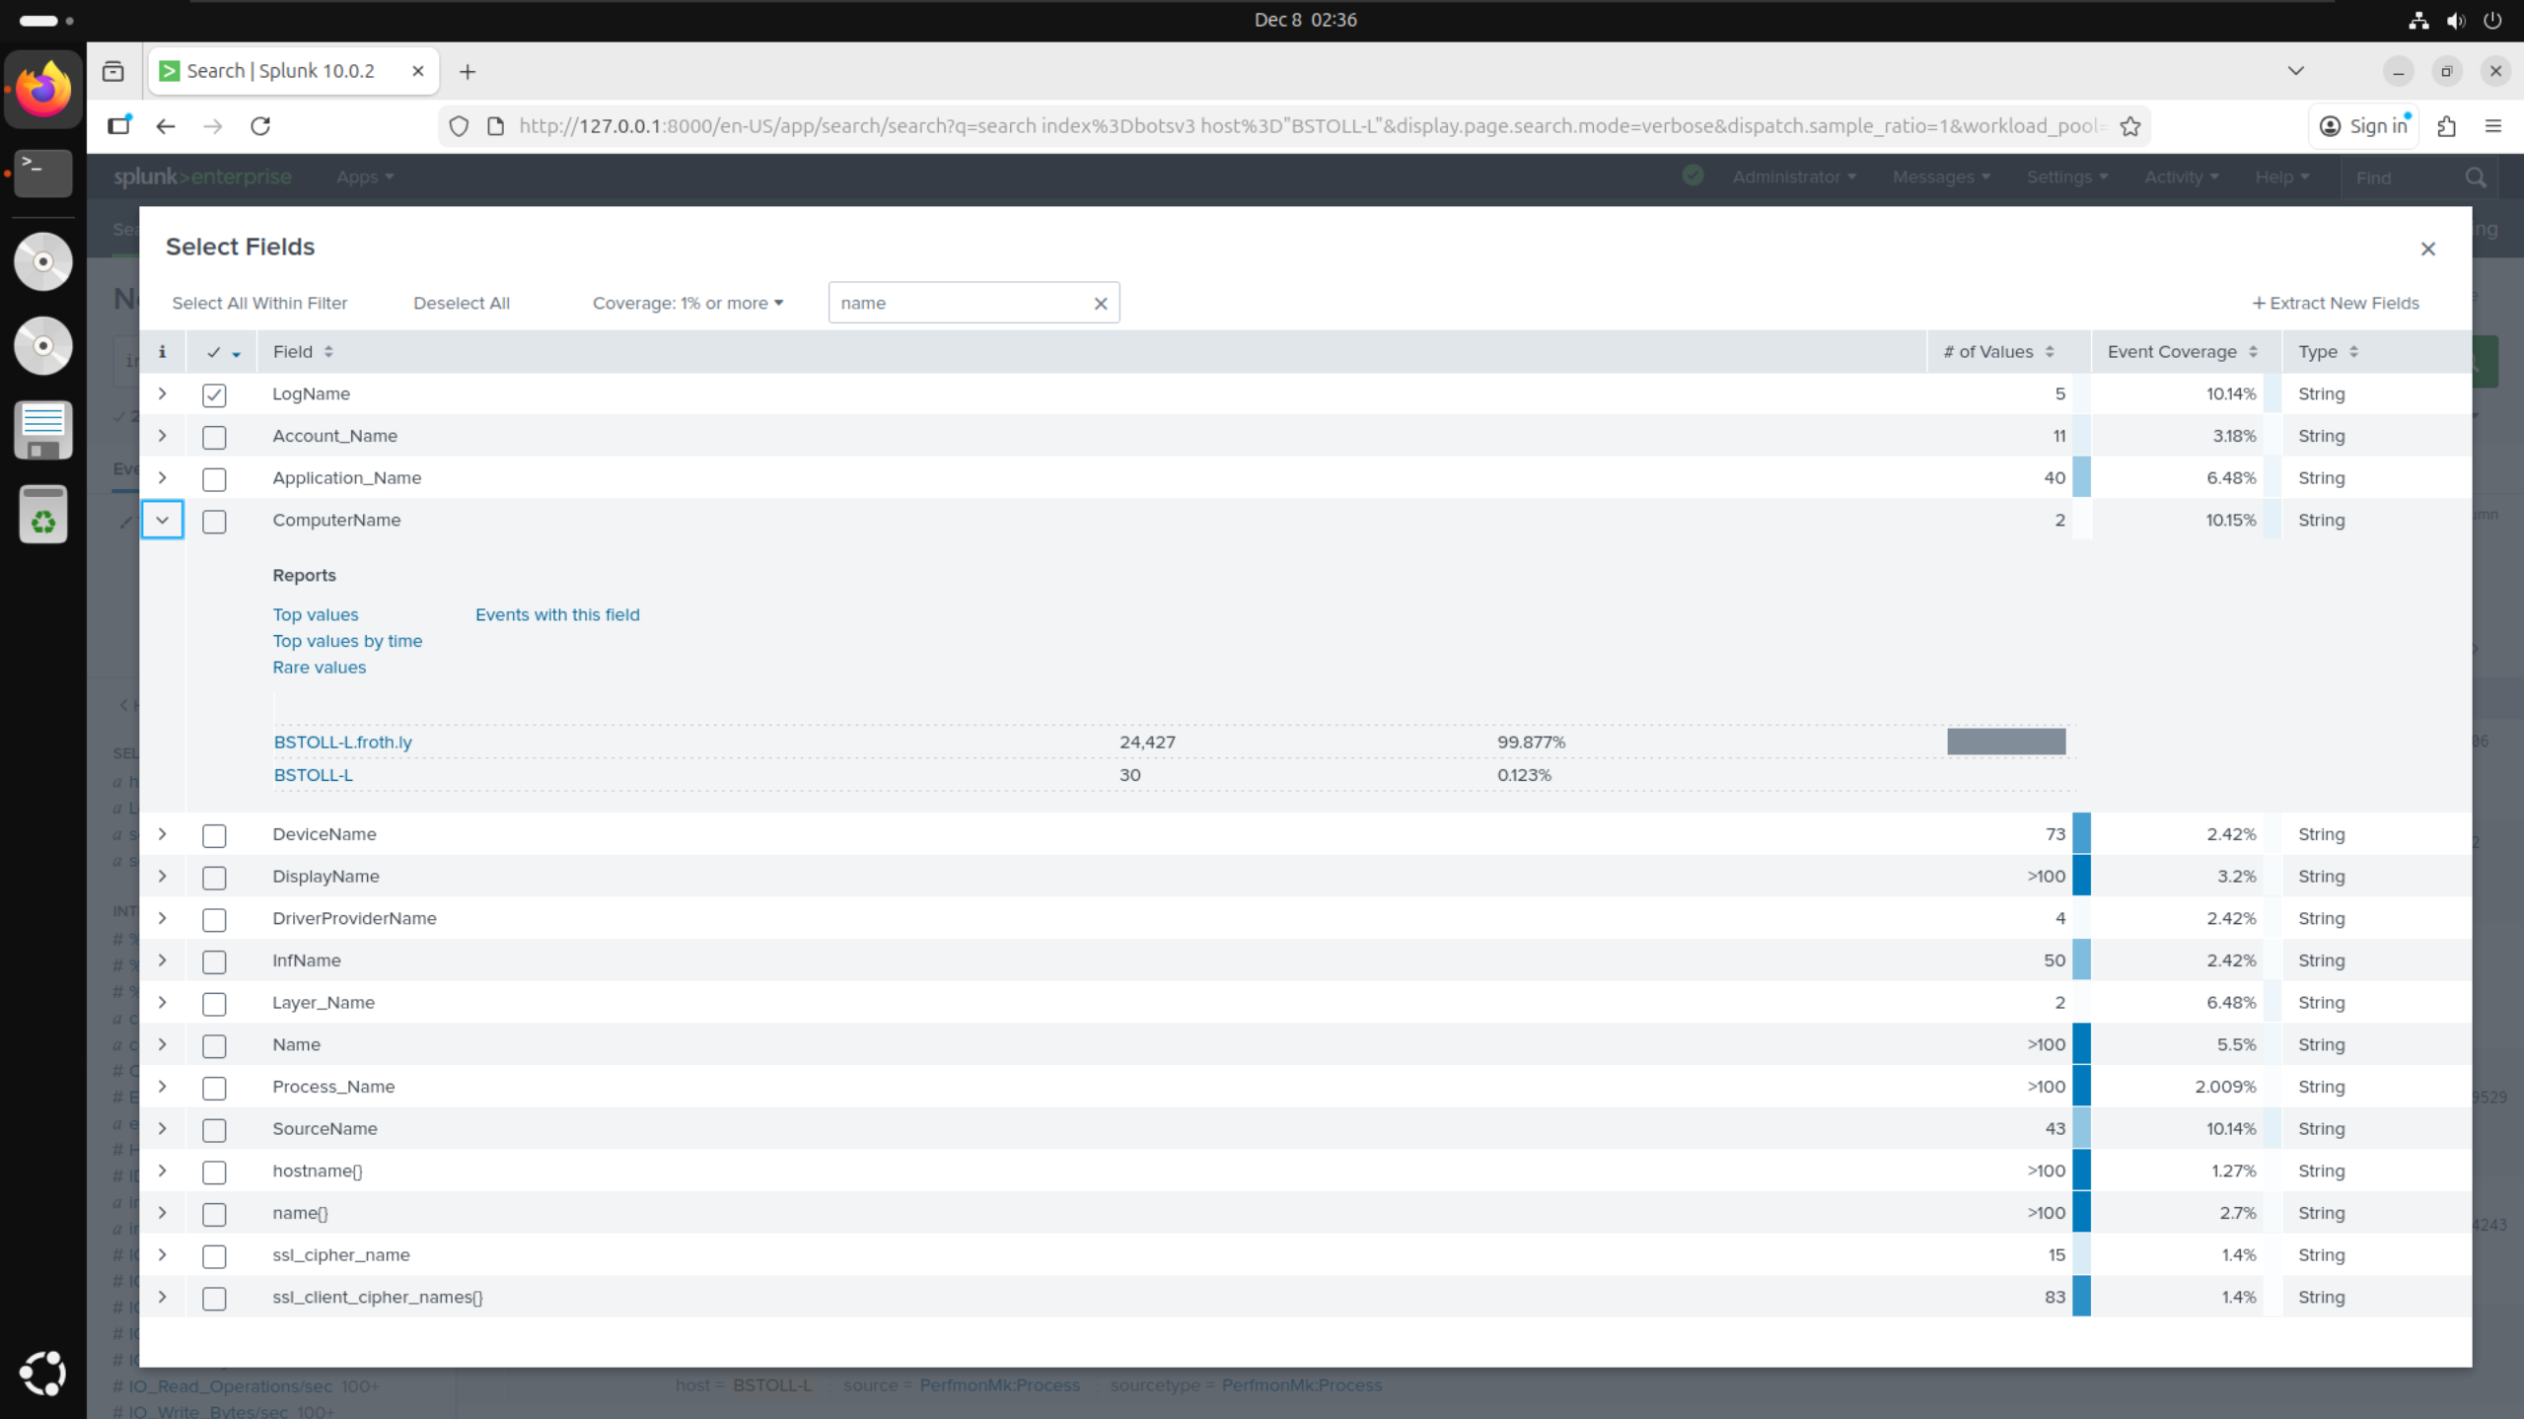

* Initially searched filters list for FQDN but could not find anything so instead searched for “name”
* Found filter called ComputerName which had the value of BSTOLL-L.froth.ly

# Conclusions:

# References: